Reporting Suspected or Disclosed Child Abuse
The following steps should be taken in reporting child abuse to the statutory authorities.
- Observe and note dates, times, locations, and contexts in which the incident occurred or suspicion was aroused, together with any other relevant information.
- Report the matter as soon as possible to the club designated safeguarding children officer (DSCO) with responsibility for reporting abuse. If the DSCO has reasonable grounds for believing that the child has been abused or is at risk of abuse, s/he will make a report to the Health and Social Care Trust (HSCT) who has statutory responsibility to investigate and assess suspected or actual child abuse. The national DSCO should be informed as soon as possible that there is a safeguarding issue to enable them to take responsibility for dealing with the matter or to support the club DSCO and monitor the situation;
- In cases of emergency, where a child appears to be at immediate and serious risk and the DSCO is unable to contact a duty social worker, the police authorities should be contacted. Under no circumstances should a child be left in a dangerous situation pending intervention by the HSCT.
- If the DSCO is unsure whether reasonable grounds for concern exist s/he can informally consult with the local statutory agencies. S/he will be advised whether or not the matter requires a formal report. Clubs should ensure they have out of hours contact numbers for their local Gateway Team, (regional emergency social work number 028 95049999)
A designated safeguarding children officer reporting suspected or actual child abuse to the statutory authorities will first inform the family of their intention to make such a report, unless doing so would endanger the child or undermine any further investigation
If you are concerned about possible abuse seek advice from the Gateway Team or contact the NSPCC Helpline on 0808 800 5000.
Remember - It is not the responsibility of anyone working in a paid or voluntary capacity, or those working in affiliated organisations, to take responsibility or to decide whether or not child abuse is taking place.
However - There is a responsibility to protect children in order that appropriate agencies can then make enquiries and take any necessary action.

Responding, recording and reporting issues of poor practice or abuse.
A central goal for all involved in children’s sport should be to provide a safe, positive and nurturing environment where children can develop and enhance their physical and social skills. Promoting a child-centred ethos should go hand in hand with identifying and eliminating practices that impact negatively on safe and enjoyable participation in children’s sport. It is essential that all those involved in youth sport feel confident to challenge poor practice and report possible abusive situations. But the first challenge for anyone considering reporting concerns about abuse is to begin to accept the possibility that it may be happening in the first place.

Young people should have their voice listened to within sports organisations to ensure they have the trust in their club/organisations leaders to keep them safe.
Clubs/organisations should actively promote organisations contact details such as;

Childline for help and advice for young people www.childline.org.uk

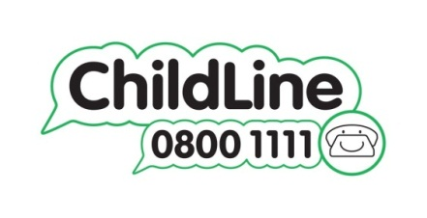
NSPCC helpline to report your concern or get advice and support contact by phone, text or online
Telephone: 0808 800 5000
Text: 88858
Email: help@nspcc.org.uk

