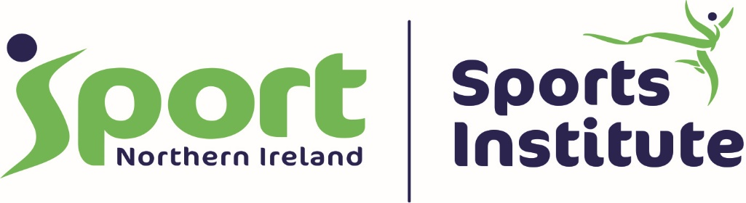

Sport Northern Ireland Athlete Privacy Notice (Adults)

Introduction
We’re here to support your performance. To do this, we need to collect, use, store and share your personal information, including sensitive information such as your health records.
This notice explains how we do this, and sets outs your rights. Finally, we ask for your consent to use and share your personal information.

Finding out more
This Notice provides a summary of our full Privacy Notice. You can read the full Privacy Notice at http://www.sportni.net/about-us/foi/privacy-notice/

Who are we?
For the purposes of the Data Protection Act 2018, SPORT NORTHERN IRELAND, House of Sport, 2a Upper Malone Road, Belfast, County Antrim BT9 5LA are the data controller of your information. Our ICO Registration number is Z8579526.

What information do we collect and use?
To be able to support you, we need to collect the following personal information:
• name
• address
• contact details including address, email and telephone number
• training notes and competition history
• details of coaches and staff outside of Sport Northern Ireland who are currently or previously supported your training

Sport Northern Ireland collects this as part of entering into a contract to support you.
We also collect the following special category information:
• health history
• ethnicity
• nutritional records
• medical records, including physical and mental health records
• medical images, including X-rays, scans and video footage
• photographic and video images of your performance to help your support team improve your performance

We ask for your consent to allow us to collect, use and share this information at the end of this Notice.
How do we use your information?
We use your information for the following things:
• To help your performance, and assess how it’s going
• To help treat any medical issues
• To help Sport Northern Ireland monitor and evaluate its own practice
• To help research better ways of working with athletes

Your rights over your personal information
You have a number of rights regarding your information:
1. We must use your information fairly, and within the law.
2. We can only use your personal information for the reasons we’ve set out here
3. We must only collect the information needed to provide you a service, and nothing more.
4. We must keep your information up to date.
5. We can’t keep it for longer than necessary.
6. We must keep your information safe.
Sometimes, Sport Northern Ireland uses apps and machines that produce automated decisions based on your information. The law allows you to ask a person to undertake that test instead. Sometimes, this may not be possible, and we’ll explain this at the time.

Who do we share your information with?
For us to be able to support you, we need to share your information with different teams within Sport Northern Ireland and with outside organisations.
Some examples are:
• Sending your medical information to a sport doctor at a hospital
• Sharing your training notes with your coach and sport’s governing body
• Sharing your information across one support team to another within Sport Northern Ireland.

When we share your personal information, we make sure we do it safely, and any person who receives it has a duty to protect it.
People working for, or on behalf of, Sport Northern Ireland who may see your personal information include:
• Sports Doctors
• Physiotherapists
• Clinical Psychologists
• Exercise Physiologists
• Podiatrists
• Counsellors
• Performance Advisors
• Performance Nutritionists
• Performance Lifestyle practitioners
• Sports Psychologists
• Skill Acquisition practitioners
• Strength and Conditioning practitioners
• Massage Therapists
• Sport Northern Ireland staff responsible for entering or updating your records.

We may also need to share your information with people who work outside Sport Northern Ireland, including:
• Your national sport governing body’s Performance Director
• Your Coach
• Medical staff and doctors in other organisations
• High Performance Managers
• Any bodies that may have funded you
• Team Ireland, NI or UK sport bodies
Every athlete is different, so we might not share your information with everyone listed here, and sometimes we may need to share your information with other people not listed here.

What happens if I don’t want Sport Northern Ireland to use my personal information?
You can tell us to stop using or sharing your personal information at any time, but this may prevent us from providing you a service. Please contact the Sport Northern Ireland Data Protection Officer, Clare McGinley, if you want advice on this, or to ask us to stop using your information. Clare can be contacted by telephone on 02890381222 or email claremcginley@sportni.net
Sometimes, Sport Northern Ireland may have to use or share information without your permission, such as to assist in crime prevention or other lawful reasons.

Storing your information electronically
Sport Northern Ireland uses a number of apps, software programmes and devices to improve your performance. These services must keep your information safe.
Some of these services use or store your information outside of the European Union.

How long does Sport Northern Ireland keep my information?
Sport Northern Ireland will keep your information all the time you are with us and/or for no longer than 10 years. We won’t keep information for longer than is necessary.

Questions or advice
If you have any questions, or want further advice regarding anything here, please email claremcginley@sportni.net, or write to Data Protection Officer, Clare McGinley, Data Protection Officer, House of Sport, 2A Upper Malone Road, Belfast, BT9 5LA.

