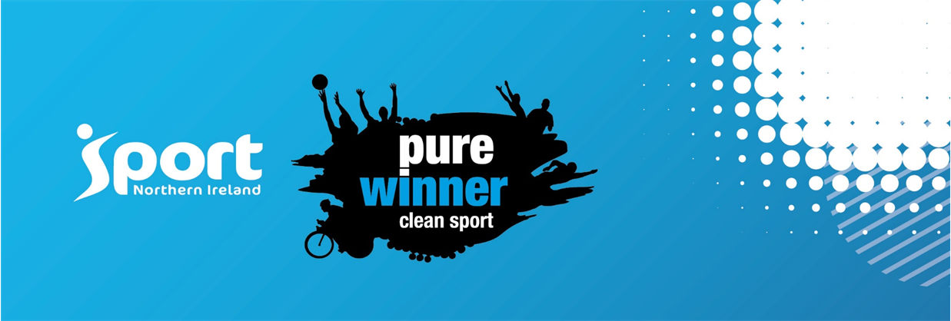
Anti- Doping Update

World Anti-Doping Agency (WADA) Prohibited List 2022
It’s that time of year again when the Prohibited List has been updated following an extensive consultation process. WADA has now published the 2022 List of Prohibited Substances and Methods which comes into effect on 1st January. If you are an athlete who may be drug tested, coach or athlete support personnel we recommend you check out the links provided for a summary of the recent changes to the WADA Prohibited List which include changes to Salbutamol and Glucocorticoid injections - WADA , WADA Summary of Changes, and UKAD

Always remember that additional substances or methods may be added to the List at any time during the year but this will only occur after a three month notice period. | 