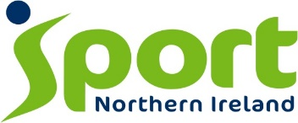
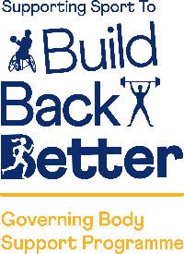
Expression of Interest
Organisation:
Registered Address:
Lead Contact:
Lead Contact Email:
Lead Contact Mobile:
- Club Membership & Infrastructure
Please state below the number of club members and clubs in Northern Ireland that are affiliated to your organisation for the specific timeframes detailed. This investment will see a contribution to Outcome 1: People in Northern Ireland are adopting and sustaining participation in sport and physical recreation. Therefore, it is important to only include those club members that are active participants within your sport.
Affiliated Club Members & Clubs | At 31st March 2019  (2018/19) | At 31st March 2020  (2019/20) | At Present  (2020/21)
Total Number of Club Members
(in Northern Ireland)
Total Number of Clubs
(in Northern Ireland)

2. Eligibility - You will need to confirm that:
Confirm each eligibility criteria below with an ‘X’ in the relevant boxes
- Your organisation is a Sport NI recognised governing body of sport.
(Where the Branch is the recognised organisation there must be agreement with the National Governing Body for either organisation to submit a proposal. Only one submission per sport.)
- Your organisation did not receive Sporting Clubs Programme investment for the period 2017-21.

3. Organisation Type
Please confirm your type of organisation with an ‘X’ in the relevant box, and if required your associated number.
Registered Company |  | No.: | Voluntary & Community
Registered Charity |  | No.: | Overseas*
Other |  | Please State:
*Overseas relates to organisations whose registered address is outside of the United Kingdom.

For Office Use Only:
Date Received:
URN: | GBSP/21/

