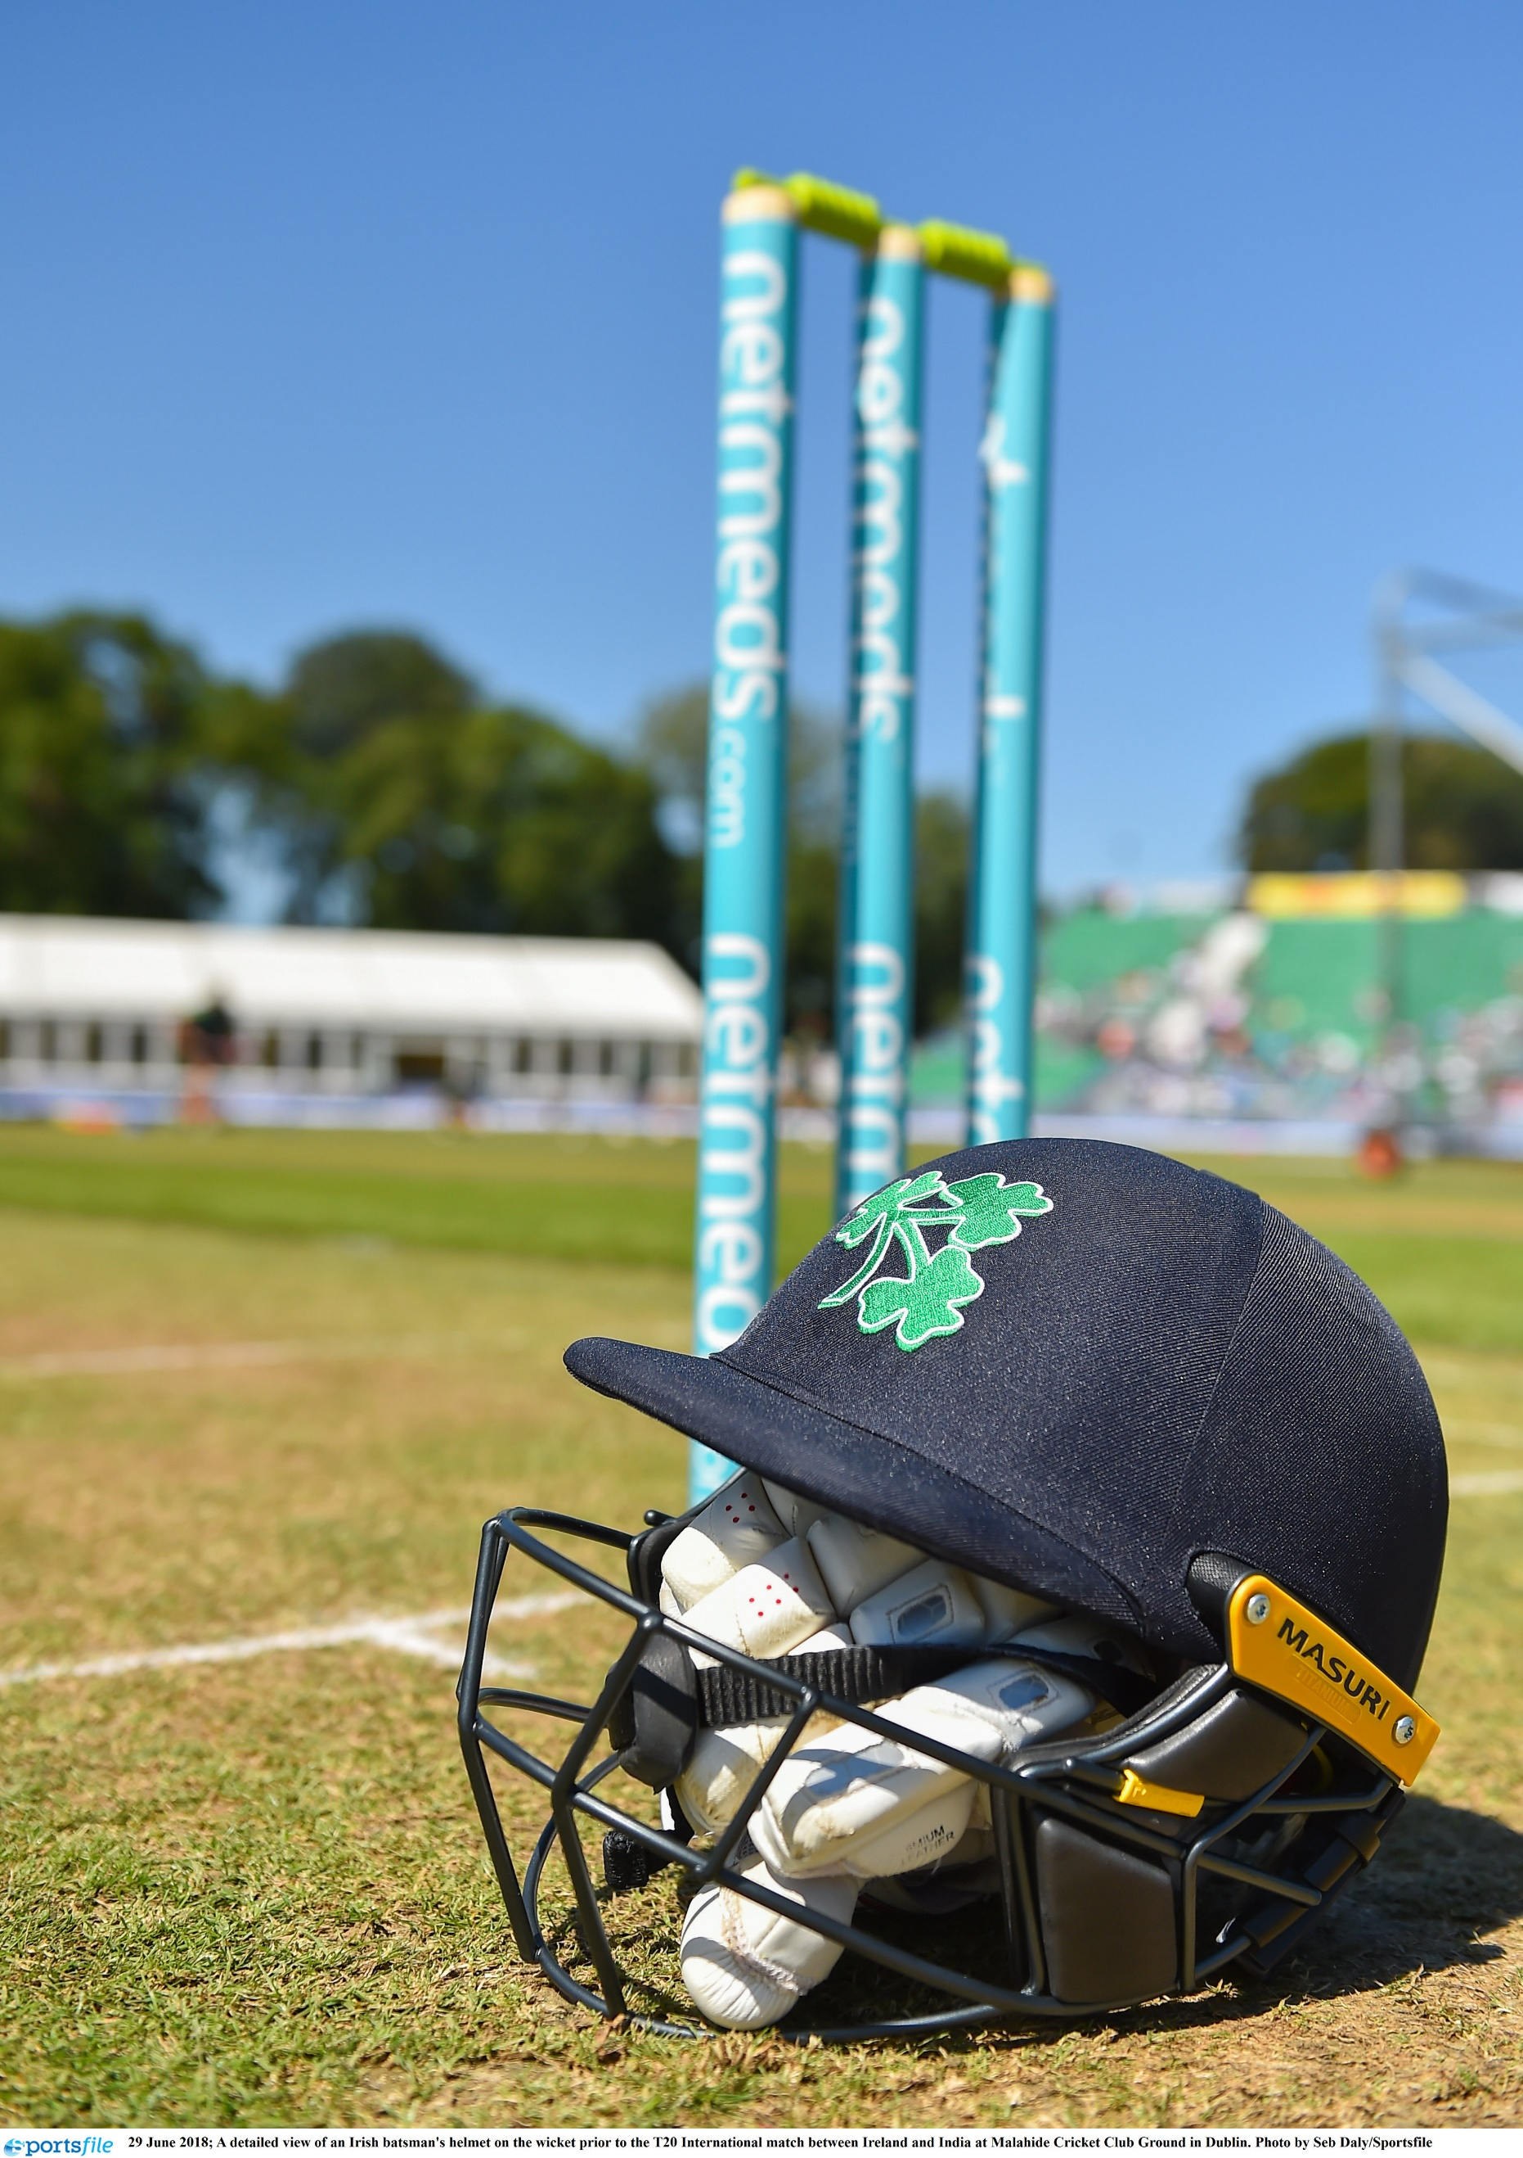

Business Development Manager
Candidate Brief

CRICKET OPERATIONS MANAGER
BACKGROUND

Cricket Ireland is the governing body for the men’s and women’s game throughout Ireland, with ultimate responsibility for its national and international aspects. The future of Irish cricket is very bright given the growth of the sport driven by significant success on the international stage in the last decade leading to an unprecedented visibility for Irish cricket at home and abroad.
Our emergence as a sport of national significance is growing following the elevation of Cricket Ireland to ICC Full Membership and Test Status, along with entry into the sport’s Future Tours Programme (FTP) that now sees Ireland playing all three formats of the game at the highest level for the foreseeable future.

Cricket Ireland’s new Strategic Plan 2021-2023 is part of a two-stage approach designed to synchronise with the ICC funding cycle to ensure that resources will be available for a more expansive strategy from 2024 onwards – with the entire span of the period 2021-2031 shaped to deliver the overall vision to ‘Make Cricket Mainstream’ in Ireland.

COMMERCIAL PROGRAMME

The strategic plan outlines the need to invest further in our foundations to ensure we have a stronger, more sustainable platform to realise our longer-term vision and objectives. The generation of significant and sustainable commercial income will be one of the primary means of building this platform, albeit that the Board is equally cognisant of the importance of the visibility and reach of the game domestically to help achieve the overall vision to ‘Make Cricket Mainstream’ in Ireland.

The recent completion of a six-year broadcast deal, our presence in the men’s FTP, the possibility of qualification for the ICC Women’s Championship, the creation of attractive ‘best v best’ elite domestic competitions, and the recent development of a live-streaming production deal gives Cricket Ireland the opportunity to exploit these opportunities and to strengthen Irish cricket for its next phase of growth.

This rapid expansion of commercial opportunities, in tandem with our existing commercial activities, now needs to be successfully managed and cultivated using existing and modern methods of onboarding and retaining commercial partners, in order to drive our growth.

ROLE AND PURPOSE OF THE POSITION

Reporting to the Chief Executive Officer (CEO), this newly established role of Business Development Manager will take responsibility for driving aspects of the organisation’s commercial revenue growth. You will successfully seek to exploit existing commercial properties, create innovative commercial programmes, coordinate and line-manage the commercial portfolio and ensure the appropriate delivery and management of commercial partner rights and programmes.

KEY RESPONSIBILITIES

- Managing Cricket Ireland’s sponsors and commercial activity.
- To assist in developing the Cricket Ireland commercial strategy in conjunction with the Senior Leadership Team (SLT) in accordance with our strategic plan.
- To develop new business opportunities and revenue streams, providing creativity and innovation to continue to grow and develop revenues in line with the commercial strategy.
- To take the lead role in identifying and developing relationships with potential sponsors, and proactively lead on contract negotiations.
- Maintain strong and effective relationships with existing sponsors.
- Work with the Events team to ensure that sponsor requirements are fulfilled/fully serviced at Home International games, competitions and any other event.
- Maintain and increase corporate membership numbers and revenue for Cricket Ireland.
- Work with the relevant teams on corporate hospitality and ticketing including pricing, sales and delivery.
- Ensure existing and new commercial opportunities are aligned with the company vision, values and strategy.
- As strategic changes and opportunities evolve, ensure consistent market execution is developed and maintained.
- Actively engage with Marketing in relation to lead generation and promotions
- Collaborate with the Marketing and Communications (MarComs) team to provide the organisation with business strategy in the areas of digital marketing (Performance & CRM), customer-focused strategy (segmentation, acquisition, and retention), fan engagement, eCommerce, digital technologies, platform development, digital content and asset monetisation.
- Work with Events and MarComs to deliver the Annual Awards.
- Provide support and advice to member Provincial Unions (PU), coordinate commercial activities to ensure harmony across properties, and creatively explore opportunities for PU partners to activate off Cricket Ireland commercial programmes/activity.
- Actively identify opportunities for accessing philanthropic funding to support playing programmes and infrastructure development.
- Support Participation Department with sponsorship and commercial opportunities for the various participation programmes.
- To prepare and manage budgets for department in line with business requirements
- To issue regular reports on pipeline activity and opportunities to SLT/Board.

EXPERIENCE AND COMPETENCIES

- Degree in business or related field.
- 5+ years’ experience in business development, ideally within a sporting environment.
- Proven track record of sponsorship acquisition.
- Results-focused with high-value selling, negotiating and persuasive skills with a demonstrable track record.
- Experience with planning and developing strong sales pipelines.
- Proven ability in developing, implementing and measuring sales and commercial activities.
- Evidence of decision-making capabilities with good commercial judgement. Strong evidence of managing and developing key relationships.
- Excellent written and oral communication skills with the ability to present at senior executive level.
- Strong financial ability - able to develop a practical system of results to monitor progress against operating plans and objectives.
- Experience of creating and managing budgets.
- Excellent interpersonal skills to develop and manage relationships with key stakeholders both internal and external.
- Strong leader, with experience of successfully leading and managing diverse and virtual teams.
- An interest in sports is essential, a cricket interest is desirable.
- Given the nature of the role, ability to travel and from time to time work unsocial hours including evenings, weekends and public holidays.

TERM AND TENURE

- Full-time and as is our current policy, for an initial fixed term of two years.

REMUNERATION

- The package will include a salary within the range of €55,000 – €65,000, plus benefits including bonus/commission and car allowance. benefits commensurate with qualifications and experience.

PROCESS

- Please note that applicants must have current eligibility to work in ROI & the UK and a full clean driving licence.
- A letter from the applicant describing what he or she would bring to the role and a concise CV setting out how and when the relevant experience has been gained should be sent by email to recruitment@cricketireland.ie for the attention of Human Resources. Please also state where you saw the vacancy.
- Interviews will be either online or face-to-face, depending on prevailing Government restrictions.
- Desired role starting date – as soon as practicable, dependent upon notice etc. of the successful candidate.

