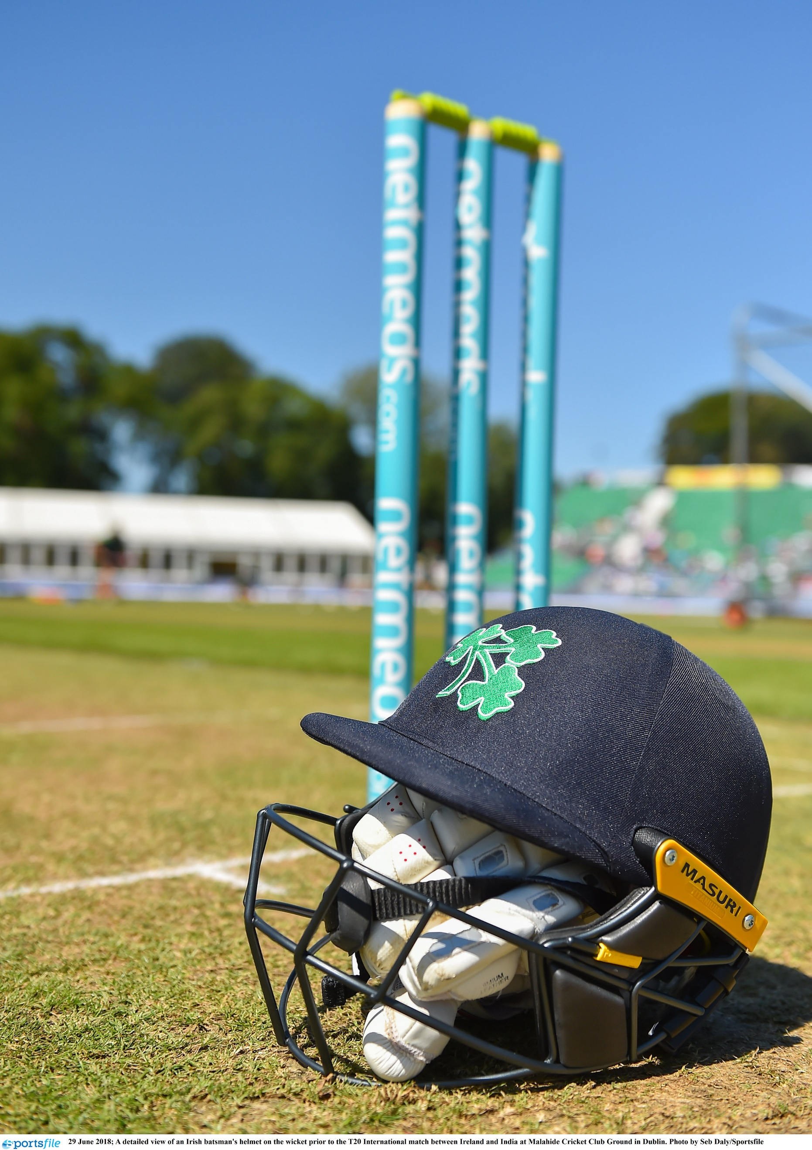

Communications Co-ordinator
Candidate Brief

CRICKET OPERATIONS MANAGER
BACKGROUND

Cricket Ireland is the governing body for the men’s and women’s game throughout Ireland, with ultimate responsibility for its national and international aspects. The future of Irish cricket is very bright given the growth of the sport driven by significant success on the international stage in the last decade leading to an unprecedented visibility for Irish cricket at home and abroad.
Our emergence as a sport of national significance is growing following the elevation of Cricket Ireland to ICC Full Membership and Test Status, along with entry into the sport’s Future Tours Programme (FTP) that now sees Ireland playing all three formats of the game at the highest level for the foreseeable future.

Cricket Ireland’s new Strategic Plan 2021-2023 is part of a two-stage approach designed to synchronise with the ICC funding cycle to ensure that resources will be available for a more expansive strategy from 2024 onwards – with the entire span of the period 2021-2031 shaped to deliver the overall vision to ‘Make Cricket Mainstream’ in Ireland.

ROLE AND PURPOSE OF THE POSITION

This is a 12-month contract position responsible for the co-ordination and roll out of communications and digital programmes and will support the Marketing Communications department on a wide range of programmes and projects aimed at meeting the strategic priorities for cricket in Ireland, together with providing backup on media services for the organisation.

You will also have shared responsibility for maintaining the Cricket Ireland digital channels in conjunction with the Media & Communications Manager.

You will be working in a small team in a very fast-paced, hands-on environment. While supporting the international team’s environment, a key focus will be on the domestic game and growing the profile, fan base and participation levels.

KEY RESPONSIBILITIES

- Co-manage the Cricket Ireland website, developing and coordinating content;
- Providing social media support for matches, events, programmes and to support corporate strategic priorities, in addition to supporting the implementation of media and communications strategies;
- Writing match reports and other media releases;
- Co-ordinate content suppliers and contractors for digital and photography services;
- Support the Marketing Manager in developing and implementing campaigns (e.g. Participation programmes, commercial activities, and events);
- Support the communications programmes around the Senior Ireland Men’s and Women’s squads, as well as national youth levels;
- Support the communications programmes around the men’s and women’s domestic cricket competitions under the management of Cricket Ireland;
- Support the management and administration of media arrangements prior to, and during, Cricket Ireland events such as matches, media days, press conferences;
- Support the delivery of livestream services and broadcast services;
- Develop strong working relationships with Provincial Unions and Clubs.

You should note that the above is not an exhaustive list and is subject to change as the job evolves.

The role is highly operational and hands-on. Written communication is highly important in this role and these skills will be tested - if selected for interview you will be tasked with preparing a written task and offering up items of published prose completed by you.

EXPERIENCE AND COMPETENCIES

- Third level qualification in Communications, Media, Digital Marketing and/or at least 2-3 years’ work experience in this area.
- An understanding of cricket, by playing, enjoying or otherwise.
- Developed written (particularly), verbal communication and relationship building skills.
- A background in media management and liaison.
- and the ability to manage multiple projects concurrently within a demanding environment;
- Strong organisational skills incorporating excellent attention to detail.
- Proven experience in managing social media platforms in a professional environment, as well as experience managing/maintaining content management systems.
- The ability to work flexible and often in a different time-zone (at times, unsociable) hours, as dictated by a sport which is largely leisure/volunteer-based.
- Full, clean driving license and access to a vehicle.
- Demonstrable working knowledge of modern Microsoft IT and software packages including Office, Word, Excel and PowerPoint.
- Ideally (but not essential) you will have a knowledge of the particular needs and challenges of working in a sporting environment and working with volunteers and a wide range of external partners to deliver programmes.

POSITION LOCATION

- Hybrid – office (in Kinsealy, Dublin), home and at various venues on match days.

REMUNERATION

- A competitive salary based on skills and experience plus pro-rated annual leave of 26 days per annum.

PROCESS

- The closing date for expressions of interest will be Wednesday 8 December at 12 noon.
- Please note that applicants must have current eligibility to work in ROI & the UK and a full clean driving licence.
- A letter from the applicant describing what s/he would bring to the role and a concise CV setting out how and when the relevant experience has been gained should be sent by email to recruitment@cricketireland.ie for the attention of Human Resources. Please also state where you saw the vacancy.
- Interviews will be either online or face-to-face, depending on prevailing Government restrictions.
- Desired role starting date – as soon as practicable, dependent upon notice etc. of the successful candidate.

