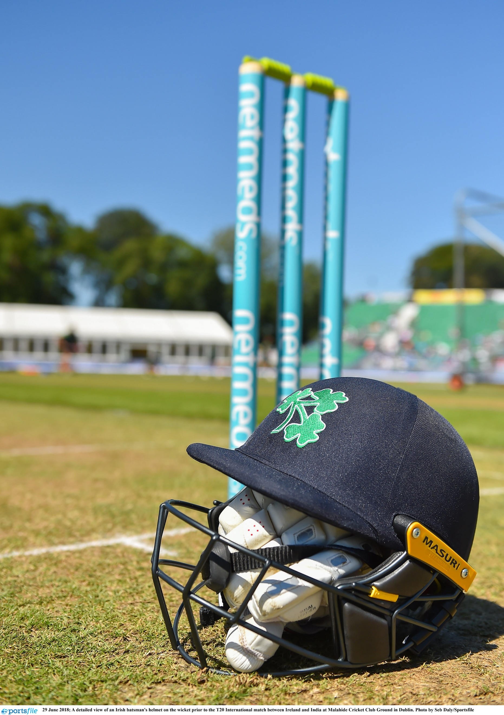

Interim Marketing & Digital Manager
Candidate Brief

CRICKET OPERATIONS MANAGER
BACKGROUND

Cricket Ireland is the governing body for the men’s and women’s game throughout Ireland, with ultimate responsibility for its national and international aspects. The future of Irish cricket is very bright given the growth of the sport driven by significant success on the international stage in the last decade leading to an unprecedented visibility for Irish cricket at home and abroad.
Our emergence as a sport of national significance is growing following the elevation of Cricket Ireland to ICC Full Membership and Test Status, along with entry into the sport’s Future Tours Programme (FTP) that now sees Ireland playing all three formats of the game at the highest level for the foreseeable future.

Cricket Ireland’s new Strategic Plan 2021-2023 is part of a two-stage approach designed to synchronise with the ICC funding cycle to ensure that resources will be available for a more expansive strategy from 2024 onwards – with the entire span of the period 2021-2031 shaped to deliver the overall vision to ‘Make Cricket Mainstream’ in Ireland.

ROLE AND PURPOSE OF THE POSITION

This is a six-month fixed term contract position reporting to the Media & Communications Manager. This interim role will have day-to-day responsibility for overseeing the delivery of various Cricket Ireland marketing strategies, including event marketing, membership, commercial and participation strategies, as well as maintaining the Cricket Ireland digital channels in conjunction with the Media & Communications Manager.

You will be working in a small team in a very fast-paced, hands-on environment.

KEY RESPONSIBILITIES

- Delivering on the content schedule for all Cricket Ireland digital channels, eNewsletters, and the Cricket Ireland website to reflect policy and marketing initiatives, developing content when required and updating information daily;
- Developing and overseeing delivery of event and match day marketing, retail strategy, ticketing strategy and supporting commercial and sponsor marketing initiatives;
- Lead the delivery of the new membership programme, including digital marketing, match day activations and administration of the membership database;
- Lead the delivery of the grassroots marketing campaign;
- Act as brand champion and guardian for the organisation;
- Support the delivery of the match livestream service with the external service provider;
- Support activities relating to promotion and delivery on government and commercial activities;
- Support the production of all Cricket Ireland publications, including the Annual Report, season guides and match programmes;
- Support the implementation of new digital and promotional programmes;
- Support the Events team with delivery of marketing around annual events (e.g. the annual Awards);
- Act as back-up support to the Media & Communications Manager and take the lead on the communications and digital support for matches when necessary;
- Coordinate and consult with stakeholders (e.g. Provincial Unions, clubs) on relevant campaigns;
- Other marketing activities as appropriate or as directed by the Media & Communications Manager.

EXPERIENCE AND COMPETENCIES

- A third level qualification specialising in marketing, communications or digital;
  - and/or demonstrate between three to five years’ relevant experience in strategic marketing, digital management and/or commercial marketing ideally in a sports-related or leisure/recreational industry;
- Experience in managing social media platforms in a professional and/or sports environment, as well as experience managing/maintaining website content management systems;
- Highly developed written, verbal, communication and relationship building skills;
- Must be highly organised with the ability to plan and deliver multiple projects and initiatives in a pressurised environment;
- Demonstrable working knowledge of modern Microsoft IT and software packages including Office, Word, Excel and PowerPoint;
- Strong administrative skills; experience with database management;
- Ideally (but not essential) you will have knowledge or interest in cricket, have or have an interest in graphic design skills, experience dealing with the media, and experience with membership (or similar) programmes.

POSITION LOCATION

- Hybrid – office (in Kinsealy, Dublin), home and at various venues on match days.

REMUNERATION

- A competitive salary based on skills plus pro-rated annual leave of 26 days per annum.

PROCESS

- The closing date for expressions of interest will be Wednesday 8 December at 12 noon.
- Please note that applicants must have current eligibility to work in ROI & the UK and a full clean driving licence.
- A letter from the applicant describing what s/he would bring to the role and a concise CV setting out how and when the relevant experience has been gained should be sent by email to recruitment@cricketireland.ie for the attention of Human Resources. Please also state where you saw the vacancy.
- Interviews will be either online or face-to-face, depending on prevailing Government restrictions.
- Desired role starting date – as soon as practicable, dependent upon notice etc. of the successful candidate.

