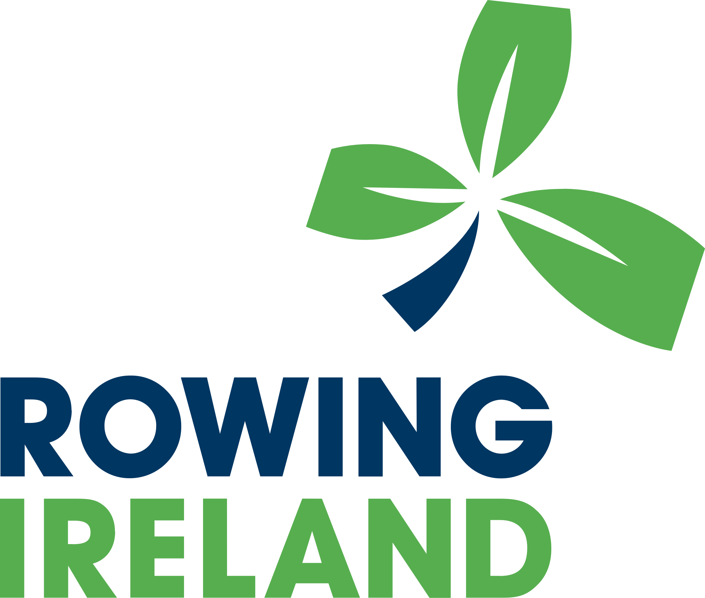

Planning and Governance Lead

Location: Dublin or Cork

Contract Type: Full-Time

Role: Planning and Governance Lead

About Us
Rowing Ireland is a membership organisation funded by Sport Ireland. We are responsible for the development and participation of flat-water, coastal, and indoor rowing across Ireland. Our work spans from grassroots engagement to the training and selection of rowers and crews representing Ireland on the international stage. At the core of our organisation are Rowing Ireland Affiliated Clubs (referred to as ‘Clubs’), which form the backbone of our community.
Our Strategic Plan 2024-2029 is built upon four key pillars:
- Participation: Driving growth in rowing across all demographics, promoting inclusivity, and ensuring accessibility to the sport at all levels.
- Performance: Enhancing pathways to elite success, supporting athletes, coaches, and teams to achieve their highest potential.
- Sustainability: Building long-term resilience for the organisation and its Clubs, ensuring financial and environmental sustainability.
- Collaboration: Strengthening partnerships and fostering connections within the rowing community and with external stakeholders.
Rowing Ireland is seeking to recruit a Planning and Governance Lead. This role will focus on ensuring compliance, financial oversight, governance, and risk management.

Role Overview
The Head of Governance and Funding will play a pivotal role in leading the implementation of a strategy to grow the sport of rowing and strengthen Rowing Ireland as an organisation. Working closely with the CEO, this role will ensure that Rowing Ireland remains compliant, financially sustainable, and fully aligned with its long-term strategic objectives.
This is an exciting time of growth and opportunity for Rowing Ireland, and the successful candidate will be a key contributor to this journey. They will be responsible for overseeing and delivering robust governance, compliance, and funding systems, enabling the organisation to perform at the highest level across all areas of operation.

Key Responsibilities

Funding and Financial support
- Manage funding applications and grant reporting, ensuring compliance with Sport Ireland and Sport NI requirements.
- Maximise the opportunities afforded by new funding streams such as additional grant opportunities

Oversee the preparation of the annual budgets, ensuring alignment with strategic objectives.

Ensure financial controls, reporting, and compliance are upheld in by the Finance Lead.
- Oversee financial records are accurate, transparent, and in line with governance best practices.

Governance and Compliance

Ensure adherence to corporate governance best practices, including compliance with Sport Ireland and Sport NI Governance Codes.

Coordinate maintenance of organisational policies and procedures (Governance)
- Provide governance updates and reports to the CEO and governance committee
- Ensure compliance with GDPR by ensuring all policies and procedures are in place with staff, athletes, board and volunteers

Risk Management

Develop and implement a risk management strategy, reporting risks to the CEO.
- Monitor and manage the risk management register
- Identify, assess, and mitigate organisational risks, ensuring proper contingency planning.

Operational and Planning Support
The successful candidate will report to the CEO and work closely with her to support the effective implementation of Rowing Ireland’s strategic and operational plans. This role will contribute key governance and operational insights to ensure the organisation functions efficiently across all departments. In addition, the candidate will take the lead on operational planning and resource coordination, including the development and optimisation of systems that promote long-term sustainability and high-performance delivery in line with the organisation’s goals.

Human Resources and Organisational Development

HR management, ensuring policies and procedures are up to date.
- Ensure that staffing policies, recruitment, and training align with governance and compliance requirements.

Qualifications and Skills
- A degree-level qualification in Business, Finance, Governance, or a related field, or equivalent relevant experience. Proven experience in governance, financial oversight, and compliance management, ideally within a National Governing Body (NGB) or similar organisation.
- Strong knowledge of governance codes, risk management, and funding compliance.
- Strong ability to work collaboratively with a CEO.
- Highly organised with excellent communication and reporting skills.
- Knowledge of sports governance is desirable but not essential.
- A full, clean driving licence to allow for flexibility in working at various locations.

Reporting and Accountability
This role reports directly to the CEO, who retains overall responsibility for the governance, operations, and financial management of Rowing Ireland.

What We Offer
- A key support role in the growth and success of rowing in Ireland.
- A structured and collaborative working environment.
- Competitive salary and benefits package.
- Opportunities for professional development and career growth.
- While a presence at the National Rowing Centre and Sport HQ is required, an element of hybrid working can be agreed.

Application Process

To apply, please submit your CV and cover letter clearly outlining your relevant experience and your strategic vision for this role to our recruitment partner Conor Harty at rowingirelandjobs@hartyvirtualhr.ie by 5:00 p.m. on Tuesday 20th May 2025.

Rowing Ireland is an equal opportunity employer, committed to equality and diversity. Applications from all suitably qualified candidates are welcomed.

