EQIA and Screening flowchart and template (taken from Section 75 of the Northern Ireland Act 1998 – A Guide for public authorities April 2010 (Appendix 1).

Introduction

Part 1. Policy scoping – asks public authorities to provide details about the policy, procedure, practice and/or decision being screened and what available evidence you have gathered to help make an assessment of the likely impact on equality of opportunity and good relations.

Part 2. Screening questions – asks about the extent of the likely impact of the policy on groups of people within each of the Section 75 categories. Details of the groups consulted and the level of assessment of the likely impact. This includes consideration of multiple identity and good relations issues.

Part 3. Screening decision – guides the public authority to reach a screening decision as to whether or not there is a need to carry out an equality impact assessment (EQIA), or to introduce measures to mitigate the likely impact, or the introduction of an alternative policy to better promote equality of opportunity and/or good relations.

Part 4. Monitoring – provides guidance to public authorities on monitoring for adverse impact and broader monitoring.

Part 5. Approval and authorisation – verifies the public authority’s approval of a screening decision by a senior manager responsible for the policy.

A screening flowchart is provided overleaf.
Policy Scoping
  - Policy
  - Available data
Screening Questions
- Apply screening questions
- Consider multiple identities
Screening Decision None/Minor/Major
Mitigate
Publish Template
Re-consider screening
Publish Template
for information
Publish Template
EQIA
Monitor
‘None’
Screened out

‘Major’
Screened in for EQIA
‘Minor’
Screened out with mitigation
Concerns raised with evidence
Concerns raised with evidence re: screening decision
Part 1. Policy scoping

The first stage of the screening process involves scoping the policy under consideration. The purpose of policy scoping is to help prepare the background and context and set out the aims and objectives for the policy, being screened. At this stage, scoping the policy will help identify potential constraints as well as opportunities and will help the policy maker work through the screening process on a step by step basis.

Public authorities should remember that the Section 75 statutory duties apply to internal policies (relating to people who work for the authority), as well as external policies (relating to those who are, or could be, served by the authority).

Information about the policy

Name of the policy

Support for the delivery of the Outdoor Recreation Action Plan (2025–2026) through investment into Outscape.

Is this an existing, revised or a new policy?

Existing

What is it trying to achieve? (intended aims/outcomes)

Support the delivery of strategic outdoor recreation initiatives aimed at increasing and sustaining participation in sport and physical activity throughout the 2025-2026 period.

Are there any Section 75 categories which might be expected to benefit from the intended policy?
If so, explain how.

All section 75 categories will be expected to benefit from the policy.

Who initiated or wrote the policy?

Sport Northern Ireland, Sports Development Team.

Who owns and who implements the policy?

Sport Northern Ireland-Sports Development Team.

Implementation factors

Are there any factors which could contribute to/detract from the intended aim/outcome of the policy/decision?

YES

If yes, are they (please delete as appropriate)

- Financial: Budget constraints may impact delivery.
- Legislative: Compliance with anti-discrimination and equality legislation

other, please specify _________________________________

Main stakeholders affected

Who are the internal and external stakeholders (actual or potential) that the policy will impact upon? (please delete as appropriate)

Staff - Sport Northern Ireland (SNI), Outscape, Northern Ireland Environment Agency (NIEA), Department of Agriculture, Environment and Rural Affairs) DEARA and Department for Communities (DfC).

Service users: All people who engage in sport and physical recreation over the period of the project and those who can be provided with greater access to sporting opportunities through the delivery of the project.

Other public sector organisations: The Plan will be delivered along with public sector partners including local government, government departments, governing bodies, education bodies, community planning partners such as Outscape, Northern Ireland Environment Agency (NIEA), Department of Agriculture, Environment and Rural Affairs) DEARA and Department for Communities (DfC)..

Voluntary/community Partnerships established may include delivery agents from across the voluntary and community sectors / Outdoor Recreation Sector such as Sperrin’s Partnership, Blueway’s and various clubs from different sports.

other, please specify ________________________________

Other policies with a bearing on this policy
- Sport NI Corporate Plan (2021-2026)
- Sport NI Equality Scheme and EDI Plan
- Programme for Government (PfG) draft Wellbeing Framework
- Department for Communities Strategy 2020-2025
The implementation and success of this policy is closely aligned with and supported by:
- Sport NI Equality Scheme
- Sport NI EDI Plan
These policies set the wider organisational commitment to equality, diversity and inclusion and will act as guiding frameworks for the delivery of this investment.
Sport NI Corporate Plan Power of Sport – Sport NI’s New Five-Year Plan | Sport NI
The Sport NI Corporate Plan following significant partner consultation identified the following mission statement and outcomes which will focus its delivery across the period 2021-2026.
Mission: We are passionate about maximising the power of sport to change lives. By 2026 we want the power of sport to be recognised and valued by all.

Outcome 1: People adopting and sustaining participation in sport and physical activity.
Outcome 2: NI Athletes among the best in the world.

Sport NI believes the delivery of these outcomes will be with the implemented through a strategic approach to investing into the sports systems. These outcomes are underpinned specifically by 4 cornerstones
- Building a positive and inclusive sports culture, recognising the rights of everyone to access and participate in sport.
- Retaining a duty of care to all those engaged in the Sporting System.
- Promoting wellness and well-being.
- Targeting sport in rural communities, in disadvantaged areas and with under-represented groups.

The above will guide Sport NI’s support to the sector over the period of the corporate plan.
Programme for Government
- New Decade, New Approach – NI Executive 2020-01-08_a_new_decade__a_new_approach.pdf
- Department for Communities 5 Year Strategy 2020 – 2025 Department for Communities Building Inclusive Communities Strategy 2020-2025 | Department for Communities
- National Sports Policy 2018-2027 - Government of Ireland www.gov.ie/pdf/?file=https://assets.gov.ie/15979/04e0f52cee5f47ee9c01003cf559e98d.pdf#page=null
- Active Living: A Strategy for sport and Physical Activity DfC Active Living | About Us
- Sport NI Equality Scheme: Equality scheme for

Available Evidence: Evidence includes:
- 2023/24 Continuous Household Survey (CHS)
- POMNI and GreenspaceNI Map analysis
- 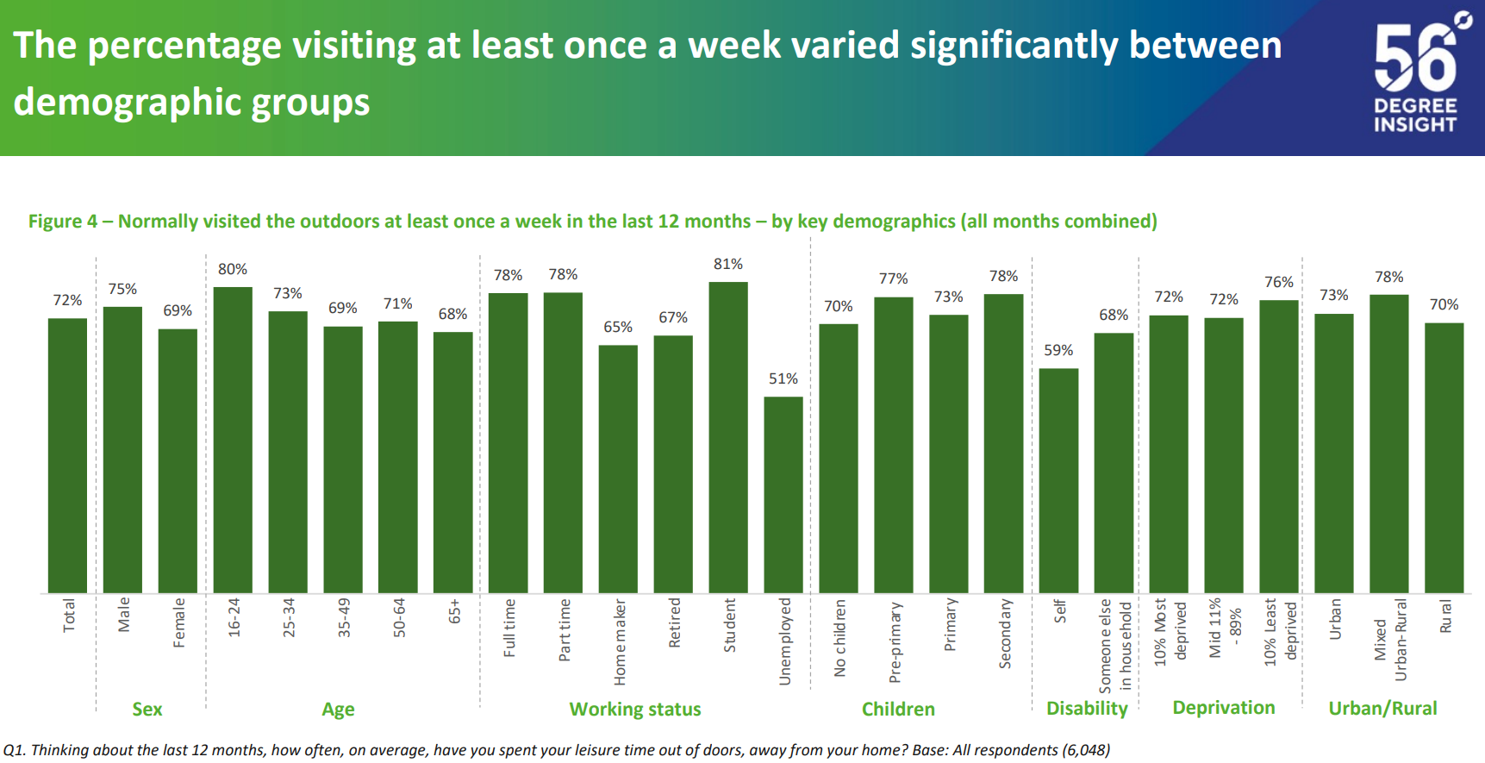
- 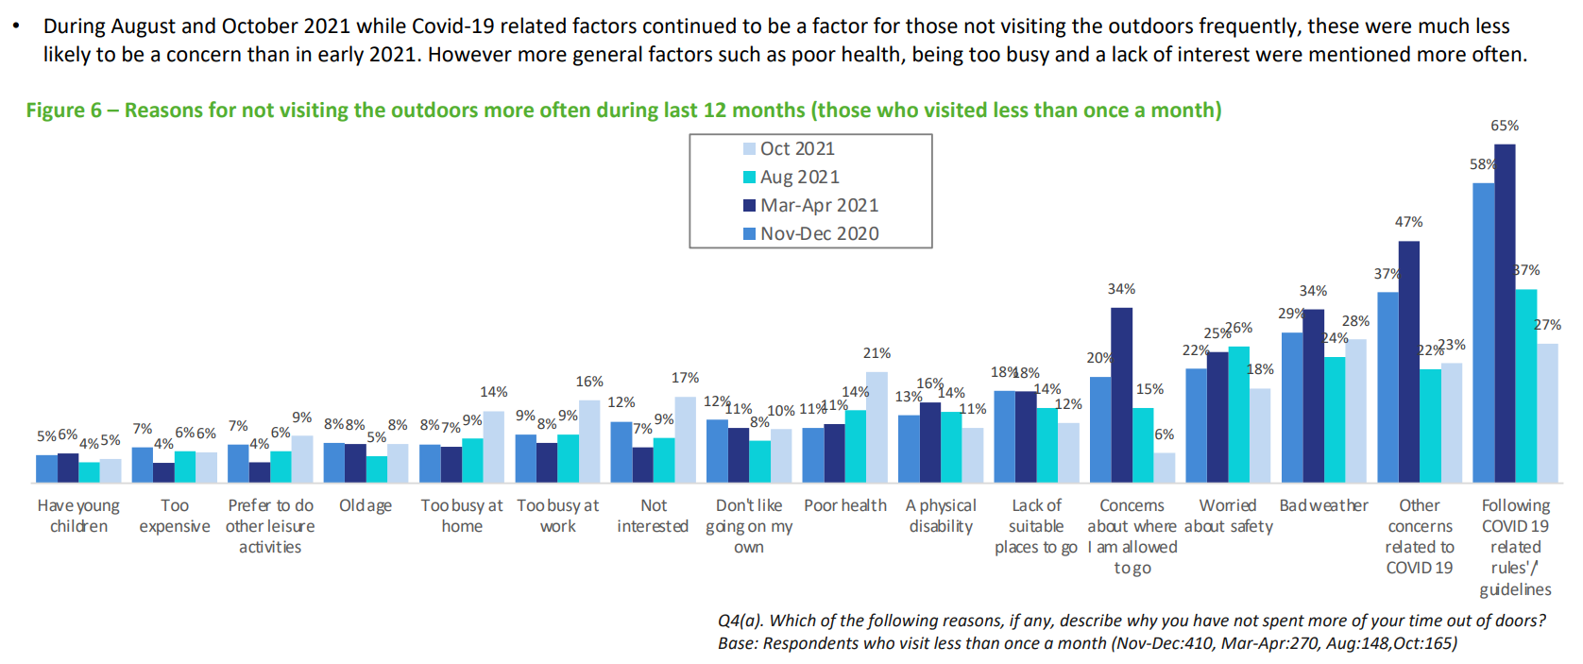
- 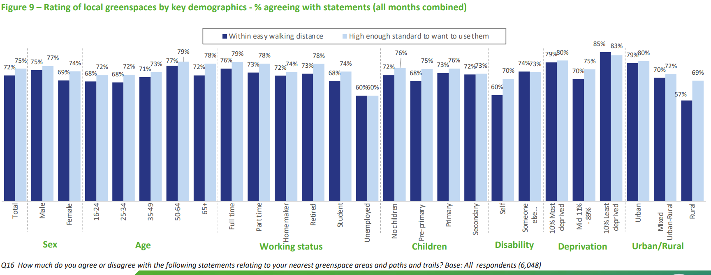
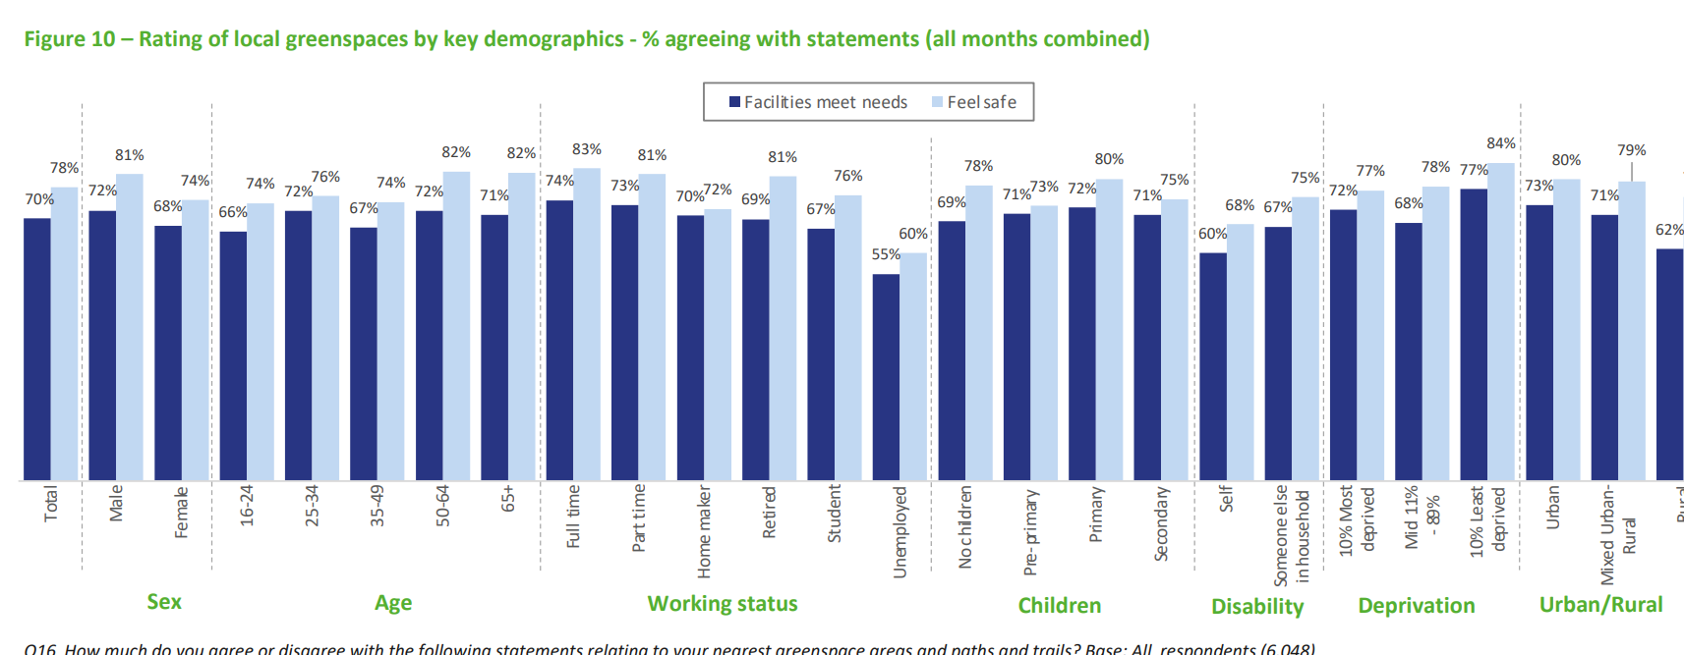
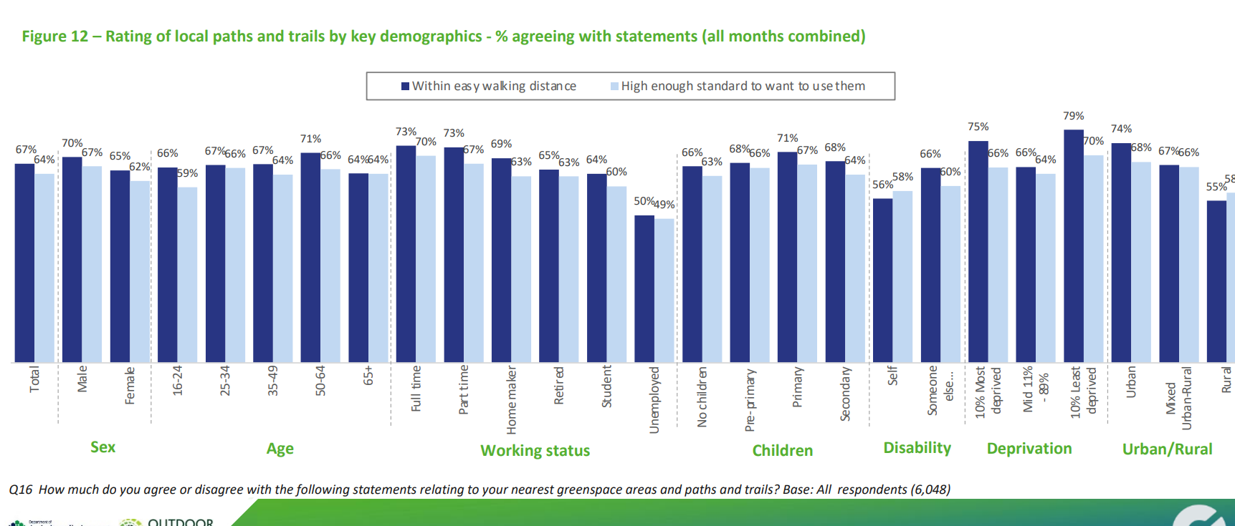
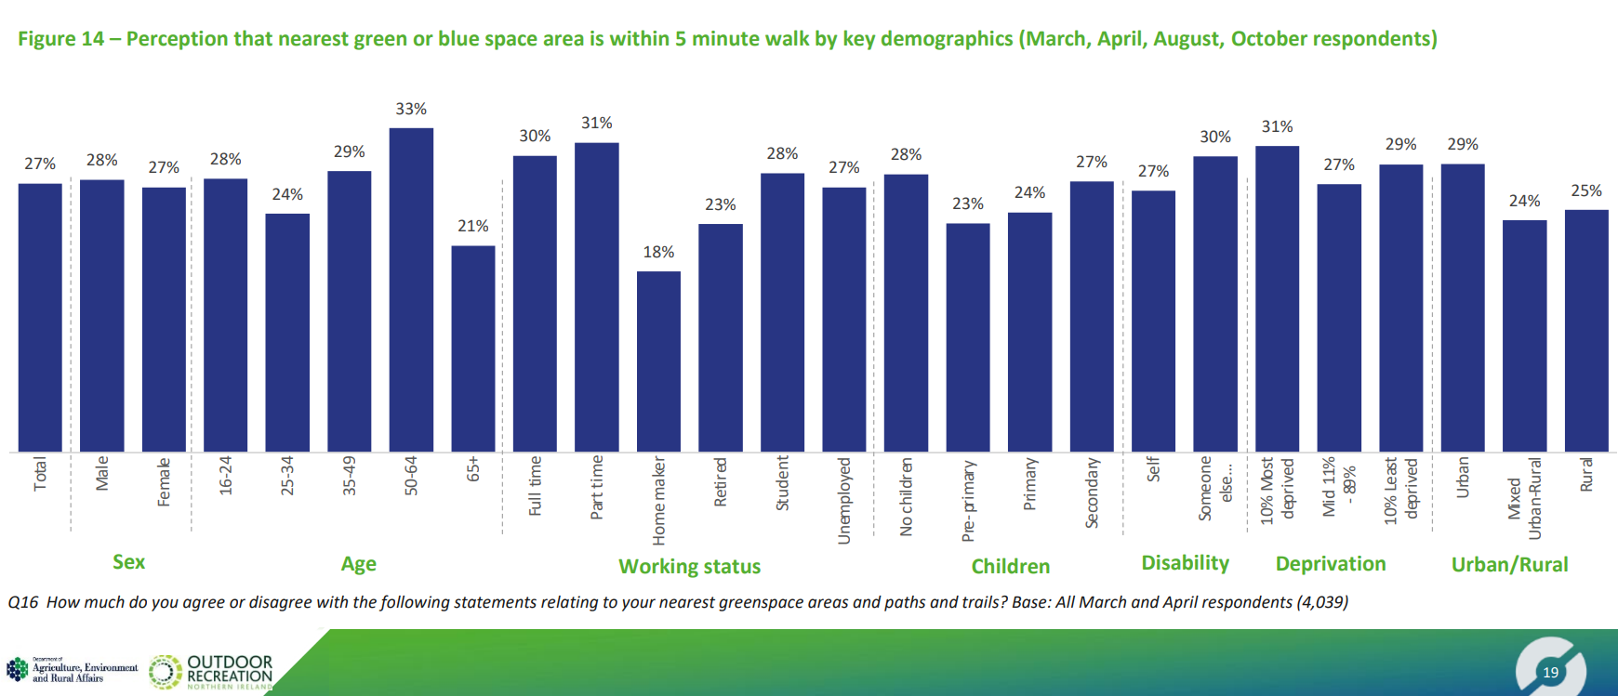
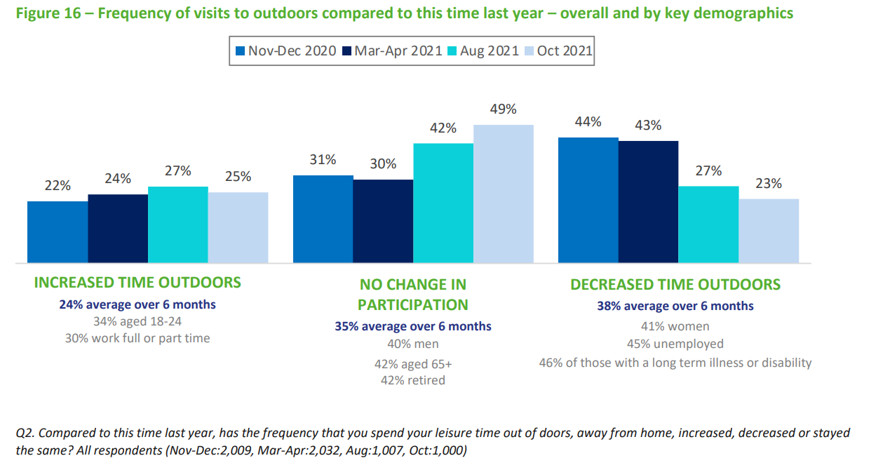
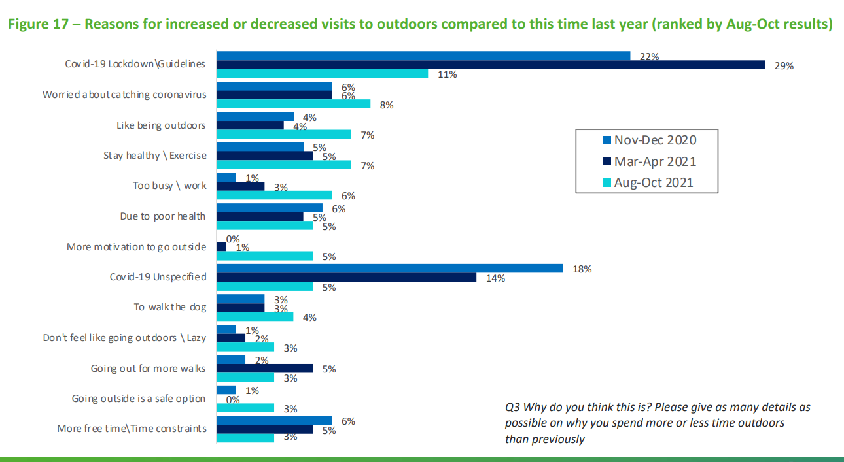

- Equality Impact Assessment (Sport NI Corporate Plan)
- Extensive stakeholder consultation (e.g. local councils, sports clubs, representative organisations)
Evidence confirms unequal access to greenspace and reduced participation among under-represented groups, especially in rural areas.
Evidence used to inform this screening process includes both quantitative and qualitative data. Sport NI has drawn on a wide range of research, consultation activities, and stakeholder engagement to ensure that investment decisions are informed by robust evidence and aligned with equality considerations.

What evidence/information (both qualitative and quantitative) have you gathered to inform this policy? Specify details for each of the Section 75 categories.

Engagement and Consultation
Sport NI undertook an extensive co-design process in developing its Corporate Plan, involving:
- A major conference bringing together key stakeholders.
- Thematic engagement workshops focused on specific areas of need.
- Public engagement surveys to gather broad-based feedback.
- Sectoral surveys targeting organisations within the sporting sector.
- One-to-one meetings with stakeholders for deeper qualitative insights.
An Equality Impact Assessment (EQIA) was carried out as part of this process, reviewing Section 75-specific data, research, and insights to ensure that equality considerations were fully integrated.
Additionally, during the summer of 2022, further consultation took place with:
- Governing Bodies
- Local Authorities
- Local sports clubs
- Other key stakeholders
Engagement was conducted through face-to-face focus groups, one-to-one meetings, and online consultation sessions. The insights gathered helped shape the priority investment areas and enablers that form the foundation of this programme.

Co-Design Approach and Equality Focus
Sport NI adopted a co-design model that emphasises a system-wide approach to sport investment. This approach was problem-solving in nature, working closely with partners and stakeholders to:
- Increase sustained participation in sport and physical activity.
- Address barriers for under-represented groups, particularly those identified under Section 75.
- Embed inclusivity, equality, and culture as key enablers to strengthen the sporting system.
Through this engagement, Sport NI has reinforced its commitment to developing an inclusive sporting system that does not treat equality as a separate concern but rather integrates it as a mainstream approach.

Data and Research Sources
Sport NI’s approach is further supported by a range of research and data sources, including:
- The 2023/4 Continuous Household Survey, which provides insight into participation trends across different demographics, including those outside of the sporting sector.
- Additional research studies specific to various Section 75 groups, offering detailed evidence on participation trends, barriers to engagement, and key equality considerations.
- Sport NI’s Equality Impact Assessment (EQIA), which summarises key evidence and findings relevant to this investment programme: Equality-Impact-Assessment-Sport-NI-Corporate-Plan.pdf.

Our Great Outdoors – The Outdoor Recreation Plan for Northern Ireland, Strategic Outdoor Recreation Group (2014)-ongoing review commenced late 2023.

Sport NI was one of the key architects of this plan with the vision of creating 'a culture of dynamic, sustainable outdoor recreation in Northern Ireland.

The aims of this Plan is to create a place where:

- There are increasing opportunities and improved access and infrastructure for sustained and increased participation for everyone in a broad range of outdoor activities.
- There are accompanying benefits to local communities, especially those who are socially excluded in terms of health, social inclusion, cohesion, equality and economic development.
- People enjoy the outdoors and show a high degree of responsibility for themselves, towards others and towards the environment they are using, and play their part in maintaining, supporting and enhancing our environment and heritage.
The Plan was developed as result of an extensive examination of the issues and a wide consultation with interested groups and individuals who contributed to the process in a range of meetings and written responses.

People in the Outdoors Monitor for Northern Ireland (POMNI):

The People in the Outdoors Monitor for Northern Ireland (POMNI) gathers evidence and trend data through an omnibus survey relating to how people in Northern Ireland engage with the natural environment, the benefits they gain from it, and the barriers they face trying to access it.

In brief summary, POMNI identified:

- 7 in 10 adults visited the outdoors for leisure each week.
- Most common activities were short walks (61%), dog walking (30%), time with children (17%) and running (11%).
- 78% say outdoor recreation was good for wellbeing, 67% for health and fitness, 41% for connecting with nature.
- People who live within a shorter walk of greenspace visit the outdoors more often.
However, the benefits of outdoor recreation are not enjoyed equally by all, those who are particularly impacted include less affluent socio-economic groups, the unemployed, those with a long-term illness or disability and those living in rural areas. See stats below:

- Members of least affluent socio-economic groups are less likely to visit the outdoors at least once a week while 13% never take visits.
- Just 51% of people who were unemployed visit the outdoors for leisure at least once a week (compared with 78% who work full time).
- 51% of people who are unemployed did not visit because of a physical disability or poor health.
- Only 60% of those with a long-term illness / disability visit the outdoors for leisure at least once a week vs 78% with no long term illness / disability.
- People with a disability are more likely to have not visited the outdoors because of a physical disability, poor health, worries about safety or because it is too expensive.
- Only 57% of those living in rural areas stated their local greenspace is within easy walking distance vs 79% of those living in rural area.

GreenspaceNI Map

- The GreenspaceNI Map (developed and managed by Outscape on behalf of the cross-governmental Strategic Outdoor Recreation Group) is a high value map of all off-road trails and publicly accessible greenspace and bluespace in Northern Ireland. It can be used by government departments and agencies, councils and eNGOs, for infrastructure planning, gap analysis, resource allocation, site suitability assessments and demographic analysis (e.g., health and deprivation etc).
- Data from the aforementioned POMNI revealed that access to greenspace is not equal across the population and that people who live closer to greenspace visit the outdoors more and derive more benefits. The population-wide survey showed that the highest number of visits were reported by those living within a 5-minute walk of greenspace, with participation rates dropping steeply for those living more than a 20-minute walk from their nearest greenspace. As such the indicator for outdoor recreation within the draft PfG Wellbeing framework is ‘Percentage of households with accessible natural space within 400 metres.
- The GreenspaceNI Map highlights specific geographic areas of need, however, in summary, the need within rural areas is highlighted i.e. only 8.71% of households within rural areas have accessible natural space within 400 metres vs 56.57% in urban areas and a 47.29% national average.

“Understanding outdoor sports participants’ motivations, connectedness to nature and wellbeing in Northern Ireland”.

Sport Northern Ireland and Tollymore National Outdoor Centre sought to better understand and support a continued surge in outdoor sport participation post COVID-19. A team from the Centre for Health, Activity and Wellbeing Research (CAWR) at Cardiff Metropolitan University was contracted to conduct a four-year project aimed at better understanding the demographic profiles of individuals participating in outdoor sports, their motivations, and the potential relationship between outdoor sport and both nature connectedness and wellbeing. Starting in 2021, the project used a cross-sectional, quantitative approach via an annual anonymised online survey (e-survey).
SUMMARY OF FINDINGS
A total of 1556 survey responses were captured across four years and the following provides a summary of findings:
- 76.5% of participants were outdoor sport club members, aged 18 - 90 years with a mean age of 50.
- Most participants identified as male 60.4% or female 38.7%, heterosexual 93%, white ethnicity 98%, and of Irish 27.6%, British 25.3%, or Both 24.1% (British and Irish) nationality. Additionally, 7% stated they had a disability, and 57% had dependent child(ren).
- The most frequently cited main outdoor sport types were cycling (n=455; 29%), hiking (n=170; 11%), angling (n=139; 9%), and orienteering (n=121; 8%).
- The mean time individuals spent per week participating in their main outdoor sport was 5.77 hours (SD = 14.61 hours), and for all physical activity was 8.66 hours (SD = 16.54 hours). On average, main outdoor sport accounted for 66.64% of all sport and physical activity completed by the participants.
- 63% (n=971) of participants reached the World Health Organization guideline of at least 150 to 300 minutes of moderate, or 75 mins vigorous aerobic activity per week in their main outdoor sport. This was irrespective of age, gender, disability, and dependent children status.
- The time spent in nature is notably higher in this study, than the amount per week thought to be associated with good health and wellbeing.
- Findings relating to the reasons for outdoor sport participation are multiple and include combinations of mental, physical, and social health benefits, and nature-based reasons, with no significant differences found across different age groups.
- Experiencing nature was the third most important motivation for both females and males for participation in outdoor sport. When exploring nature connectedness, it was found that females were significantly more connected to nature than males.
- When sport type was split into water or land-based sport, people who participants in water-based were found to have a greater association with the natural environment.
- Reflecting global population level wellbeing scores, 25% of the participants scored in the poor wellbeing or potential depression category. The mean score for outdoor sport participants in Northern Ireland was 62.12 (SD=19.1), above the low wellbeing threshold (a score of ≤ 50 ).
- The highest scored reason for outdoor sport participation was for mental health. Participating in outdoor sport for mental wellbeing was particularly important for people with a disability and people with dependent children.

This comprehensive evidence base ensures that the investment programme is data-driven, inclusive, and responsive to the needs of all communities.
Religious belief
Evidence relating to religious belief is drawn from the Continuous Household Survey 2023/24, which captures data on religious identification within the population and their engagement with sport and physical activity.
Source: Experience of Sport by Adults in Northern Ireland 2023/24
Additionally, the Equality Impact Assessment (EQIA) for Sport NI’s Corporate Plan highlights the importance of supporting sports to develop more mixed and inclusive participant bases that are not segregated along religious lines.
Source: Equality Impact Assessment – Sport NI Corporate Plan

_______________________________________________________

Political Opinion
The EQIA for Sport NI’s Corporate Plan also references research (2016) which identified the symbolic nature of sport in Northern Ireland’s divided society, where some sports can reflect religious, cultural, and political allegiances. However, the same research suggested that the politicisation of sport may be gradually weakening, indicating a potential shift toward greater inclusivity across political divides.
Source: Equality Impact Assessment – Sport NI Corporate Plan

Racial Group
Currently, Sport NI does not hold comprehensive participation data disaggregated by racial group. This gap in data was explicitly identified through Sport NI’s participation in the 2021 ‘Tackling Racism and Racial Inequality in Sport’ collaborative study, conducted alongside the other UK Sports Councils.
Source: Tackling Racism and Racial Inequality in Sport Review 2021
A key finding for Northern Ireland was that a lack of available data and insight into the racial diversity of participants in sport makes it difficult to measure progress or identify specific barriers faced by ethnically diverse communities.
The study’s lived experience component — #TellYourStory — further highlighted this issue, stating that:
“The final numbers provide sufficient data for the England analysis, but the in-depth one-to-one interviews conducted in Scotland, Northern Ireland, and Wales offer only initial insights for these countries. Low engagement may also reflect weaker networks and relationships between the Sports Councils and ethnically diverse communities at local level.”
Further contextual evidence can also be drawn from the Northern Ireland Assembly’s paper on grassroots sport, which outlines general participation trends and potential challenges across communities.
Sources:
- Grassroots Sport in NI: A Summary of Participation and Potential Challenges
- Tackling Racism and Racial Inequality in Sport Review 2021

______________________________________________________

Age
The 2023/24 Continuous Household Survey (CHS) provides the most up-to-date data on participation in sport across different age groups in Northern Ireland. Findings are available at:
Experience of Sport by Adults in Northern Ireland 2023/24.
In addition, the 2022 the Children's Sport Participation and Physical Activity Survey (CSPPA Reports – CSPPA.ie), the 2022 Children's Report Card (PA-Report-card-full-report-final.pdf) the 2023 Kids’ Life and Times Survey (focused on P7 pupils) and the Young People Life and Times Survey (focused on 16-year-olds) offer valuable insights into participation patterns and attitudes towards sport and physical activity among children and young people (Northern Ireland Kids Life and Times Survey: 2023 and (Young Life and Times Survey: Sport). These surveys highlight a clear decline in participation levels as children transition from primary to post-primary education, indicating the importance of targeted interventions to sustain participation into adolescence and adulthood.

_______________________________________________________

Martial Status
The 2023/24 Continuous Household Survey (CHS) also provides insight into sport participation rates based on marital status. This evidence helps Sport NI better understand how relationship status may influence participation. Findings can be accessed at:
Experience of Sport by Adults in Northern Ireland 2023/24.
This evidence is supplemented by the Equality Impact Assessment (EQIA) for Sport NI’s Corporate Plan, which reviewed broader research and data on participation patterns across different Section 75 groups, including marital status.

_______________________________________________________

Sexual Orientation
Currently, Sport NI does not hold robust quantitative data on sport participation rates disaggregated by sexual orientation, largely due to the absence of this data in standard population-level surveys.
However, evidence gathered through extensive consultation for the Corporate Plan highlighted a number of barriers faced by LGBTQIA+ people in sport, including:
- The invisibility of LGBTQIA+ identities within many sporting environments.
- The absence of visible role models and a reluctance among athletes to come out.
- Homophobic microaggressions and unreported hate incidents creating hostile environments in some sports settings.
- Specific challenges faced by single-identity LGBTQIA+ teams, particularly around sustainability and broader acceptance.
These insights are captured within the Corporate Plan’s Equality Impact Assessment (EQIA) and demonstrate the ongoing cultural and structural barriers impacting LGBTQIA+ inclusion in sport.

_______________________________________________________

Men & Women
The 2023/24 Continuous Household Survey (CHS) provides gender-disaggregated data on sport participation, enabling Sport NI to track differences in participation rates between men and women.
The data is available at:
Experience of Sport by Adults in Northern Ireland 2023/24.
In addition to participation rates, consultation evidence from the development of the Corporate Plan highlighted gender-specific barriers to participation, including:
- Caring responsibilities, which disproportionately impact women.
- Concerns around personal safety, particularly when accessing facilities or participating in sport after dark.
- Gendered stereotypes affecting perceptions of who sport is for and what activities are seen as appropriate for different genders.

_______________________________________________________

Disability
The 2023/24 Continuous Household Survey (CHS) also captures participation rates for disabled and non-disabled people, providing a key evidence base for understanding disparities in participation.
This data can be accessed at:
Experience of Sport by Adults in Northern Ireland 2023/24.
Alongside this quantitative data, Sport NI continues to engage closely with Disability Sport NI, gathering practical insights into the lived experiences of disabled athletes, participants, coaches, and volunteers. This qualitative evidence helps contextualise participation data and highlights barriers such as:
- Accessibility of facilities and equipment.
- Limited availability of inclusive programmes.
- Gaps in awareness and understanding among coaches and volunteers.

_______________________________________________________

Dependants
The 2023/24 Continuous Household Survey (CHS) provides further evidence on participation in sport among individuals with caring responsibilities. This data helps identify the impact of dependants on levels of participation, particularly for parents of young children, lone parents, and carers of disabled or older relatives.
Data is available at:
Experience of Sport by Adults in Northern Ireland 2023/24.
Consultation for the Corporate Plan further reinforced how caring responsibilities create a significant barrier to regular participation, particularly for women. Issues raised include:
- Lack of affordable childcare.
- Timetabling of sessions, which may not be compatible with family schedules.
- Limited availability of family-friendly sport and physical activity options.

_______________________________________________________

Needs, experiences and priorities

Taking into account the information referred to above, what are the different needs, experiences and priorities of each of the following categories, in relation to the particular policy/decision?

Specify details of the needs, experiences and priorities for each of the Section 75 categories below:

Religious belief

Current Participation Patterns
The 2023/24 Continuous Household Survey (CHS) provides the most recent data on participation in sport across different religious backgrounds in Northern Ireland. According to the survey:
- 46% of people identifying as Catholic participated in sport at least once in the previous seven days.
- 47% of people identifying as Protestant participated in sport at least once in the previous seven days.
- 56% of people identifying as ‘Other’ or having no religion participated in sport at least once in the previous seven days.
Source: Experience of Sport by Adults in Northern Ireland 2023/24

Research Insights and Consultation Feedback
Evidence from the Equality Impact Assessment (EQIA) for Sport NI’s Corporate Plan references a 2016 study (Mitchell, Somerville & Hargie) on Sport and Social Exclusion. This research found:
- Strong public support (86%) for the principle of sport as a peacebuilding tool in Northern Ireland.
- Both Protestant and Catholic communities expressed a desire for sports to become more mixed in terms of participation and support bases.
Source: Sport NI Corporate Plan EQIA
Through Sport NI’s extensive public consultation for the 2021-2026 Corporate Plan, further religious and cultural considerations were identified:
- Religious and cultural practices impact participation, particularly for some women and girls from specific faith backgrounds.
- Issues raised included the need for:
  - Female-only sessions for activities such as gym classes and swimming.
  - Private changing facilities for those unable to use communal spaces.
- The need for dedicated development officers to support participation within culturally diverse communities, helping sustain engagement and facilitate progression within sport.

Inclusive Provision and Facility Access
The Department for Communities (DfC) screening of the Active Living Strategy reinforces these priorities, highlighting:
- Facility access at times that respect religious observances.
- Programming of gender-specific sessions to align with religious and cultural requirements.
Sport NI also acknowledges that community background continues to influence sporting preferences and participation. This reality should inform the allocation of resources and the design of inclusive programmes.
Further, Sport NI respects the personal choice of athletes in relation to national representation, recognising the diverse identities within Northern Ireland’s sporting landscape.

_______________________________________________________

Political Opinion

Historical Context and Evolving Trends
The EQIA for Sport NI’s Corporate Plan references evidence (Mitchell, Somerville & Hargie, 2016) that highlights the historical politicisation of sport in Northern Ireland, where certain sports became associated with particular political, religious and cultural identities.
However, this research also found emerging evidence that the politicisation of sport may be gradually weakening, with some sports becoming more cross-community in character.

Consultation Feedback and Strategic Priorities
Through consultation on Sport NI’s Corporate Plan (2021-2026) and the Department for Communities’ Active Living Strategy, the following needs and experiences were identified for people of differing political opinions:
- Neutral and accessible facilities: Facilities should be seen as welcoming to all and free from political or sectarian symbolism that could discourage participation.
- Safe and inclusive environments: Participants highlighted the importance of feeling safe and secure when using facilities, venues, and open spaces.
- Avoidance of territorial markings: Facilities should be free from flags, emblems, murals, or other territorial markers that could alienate potential users.
Sport NI also recognises the importance of respecting personal choice in relation to international representation, acknowledging that some athletes may choose to represent Northern Ireland, Ireland, or the UK — and that this choice should be fully supported within the system.
___________________________________________________

Racial Group

Current Evidence and Research Insights
Sport NI, alongside the other Home Country Sports Councils, commissioned an extensive quantitative and qualitative research programme to better understand racial inequalities and racism in sport across the UK. This resulted in two key reports:
- “Tell Your Story” (2021) – capturing the lived experiences of people from ethnically diverse communities within sport, highlighting racism, microaggressions and structural inequalities.
- “Tackling Racism and Racial Inequality in Sport” (TRARIIS) – bringing together existing data to map inequalities in participation, representation, and experience within sport and physical activity.
Headline Findings:
- People from ethnically diverse backgrounds consistently report lower participation rates in sport and physical activity compared to White British/White Irish populations.
- Structural and cultural barriers, including language barriers, lack of visible role models, experiences of overt racism and microaggressions, contribute to lower engagement.
- Inequalities exist across all levels of sport – from grassroots participation through to elite performance and leadership roles.
- The research identified five common themes for action, which guide Sport NI’s approach:
  - Representation and Leadership
  - Embedding Anti-Racism
  - Education and Cultural Awareness
  - Data and Insight
  - Systems and Accountability
Sources:
- Tell Your Story
- Tackling Racism and Racial Inequality in Sport
- 5 Common Themes for Action

Consultation Feedback and Community Insights
Through consultation on Sport NI’s Corporate Plan 2021-2026 (‘The Power of Sport’), alongside the Equality Impact Assessment (EQIA) for the Plan, the needs, experiences and priorities of ethnically diverse communities were explored in greater detail.
Key messages from consultation included:
- Inclusive Culture:
Participants highlighted the need for a genuinely open, welcoming and inclusive sporting culture that actively promotes wellbeing and inclusion, rather than simply expecting participation.
- Cultural and Language Barriers:
Stakeholders proposed practical tools to overcome cultural and language barriers, including:
  - A multi-language app to support signposting, tailored to different confidence levels, sports and local club options.
  - Welcome videos from relatable participants to challenge stereotypes and misconceptions around sport being elite-focused.
- Tackling Racism and Bias:
Participants reported both blatant racism and subtle microaggressions in sporting environments. This aligns with the findings of the TRARIIS research and further emphasises the need for:
  - Anti-racism training for clubs, officials and coaches.
  - Stronger policies and enforcement mechanisms to challenge discrimination when it occurs.
- Targeted Development and Pathways:
Feedback highlighted the need for culturally diverse development officers, who can act as bridges between communities and the sporting system, helping build trust and sustained engagement.
- Affordability and Accessibility:
Cost was consistently raised as a barrier to participation. This includes not only membership fees, but also kit, equipment and transport costs.
Clubs and governing bodies were encouraged to explore more flexible pricing structures and targeted outreach programmes to remove these barriers.
- Pathways to Leadership and Representation:
Feedback highlighted the lack of ethnically diverse representation within coaching, officiating and governance roles. Clear pathways to leadership were seen as essential, alongside targeted mentoring and outreach.
- ‘Who You Know’ Culture:
A strong theme across consultations was frustration at the informal networks that often shape access to development and leadership opportunities within Northern Ireland sport. More transparent recruitment and targeted outreach to ethnically diverse communities were identified as a critical priority.
Outscape’s GreenspaceNI mapping further supports these findings by highlighting disparities in access to greenspace across Northern Ireland, particularly in rural and lower-income areas. This data is relevant for minority ethnic communities, who may be more likely to live in these underserved locations, reinforcing the need for targeted outdoor recreation investment

Broader Strategic Alignment
The Sport NI EQIA also referenced the Sport England “Sport for All” study (2020), which provides further evidence that:
- Different ethnic communities have diverse needs and preferences, which should inform programme design.
- People’s experiences are shaped by multiple factors, including age, gender, disability, faith, sexual orientation — meaning solutions must account for these intersecting identities.
- Systemic change requires collective action across the whole sporting system, not just at club or governing body level.
Source: Sport for All: Why Ethnicity and Culture Matters

_____________________________________________________

Age
Sport NI has reviewed a range of research and data to understand how age affects people’s participation in sport and physical activity. Key sources include the 2023/24 Continuous Household Survey, the Children’s Sport Participation and Physical Activity Study (CSPPA), and the Kids Life and Times (KLT) and Young Life and Times (YLT) surveys.
What we know from the data:
- Sport participation declines as people get older, particularly between primary and post-primary school.
- 17% of students aged 10-18 in Northern Ireland meet the recommended 60 minutes of daily physical activity.
- Boys are more likely to meet this target than girls.
- Participation rates are lower for children with disabilities and children from minority ethnic backgrounds.
- 92% of primary pupils and 76% of post-primary pupils take part in school sport outside of PE at least once a week.
What older people told us:
- They want more adapted sports like walking football, table tennis and bowls.
- Transport, costs and lack of local facilities are big barriers, especially in rural areas.
- Better communication and promotion of activities is needed.
- Feeling self-conscious about going to classes alone puts people off.
- Health concerns, lack of changing facilities and digital barriers (for online classes) also affect participation.
- There is strong support for fun, social and non-competitive activities.
- Linking with initiatives like Age Friendly programmes and ensuring sports facilities meet accessibility standards was highlighted.
What children and young people told us:
- There is strong demand for better quality PE in schools, with more focus on skill development and physical literacy, not just competition.
- Early focus on competitive sports leaves many children feeling excluded.
- School-to-club pathways need to improve to help children stay involved.
- After-school activities are often unaffordable for low-income families.
- Young people want a wider range of sports and more adventure-style activities, especially in rural areas.
- Transport, self-confidence, and stereotypes around which sports are for boys or girls are barriers.
- 17/18-year-olds feel there are fewer suitable activities for them locally.
What parents, early years staff and community workers told us:
- Early years play and fundamental movement skills are crucial but often overlooked.
- Many parents lack the knowledge or confidence to encourage physical activity at home.
- Financial pressures, lack of local support, and digital exclusion all affect family participation.
- Outdoor play and using natural environments should be encouraged, but weather is often seen as a barrier.
- Costs of clothing, equipment and club fees can exclude families.
- There’s a need for better partnerships between clubs, schools and local community groups to offer low-cost options.
- Messaging should focus on fun, health and wellbeing rather than competition.

Data from Outscape’s POMNI shows participation in outdoor activity declines with age and is affected by proximity to greenspace. This is especially important when designing age-friendly access routes and programming for older adults.
In summary:
There is clear evidence that participation levels change across the life course, with steep declines during adolescence and into adulthood. Different age groups face distinct barriers, from the cost of after-school sport for children, to transport and health concerns for older adults. The consultation highlighted strong support for improving PE in schools, providing affordable community sport for all ages, and ensuring that messaging, facilities and programmes are truly inclusive.
_____________________________________________________

Marital status

Overview
The 2022/23 Continuous Household Survey (CHS) gathered data on participation in sport. Findings related to marital status are available in the published tables: engagement-culture-arts-heritage-sport-by-adults-in-northern-ireland-202223.xlsx (live.com).
Participation levels by marital status were as follows:
- Married / Cohabiting: 50%
- Single: 52%
- Widowed: 21%
- Separated / Divorced: 36%
More recent data from the 2023/24 Continuous Household Survey (CHS) indicates:
- 51% of married people had participated in sport within the previous 7 days.
- 54% of single people had participated in sport within the previous 7 days.

Needs, Experiences and Priorities
The Department for Communities’ screening assessment on the Active Living Strategy highlights several factors affecting participation across different marital status groups:
- Access to facilities at times that fit around family and work commitments.
- Encouraging parental involvement in children’s sports and physical activity.
- Childcare issues are a significant barrier for many parents, particularly those in dual-working households.
- Cost is a limiting factor, particularly for those on lower incomes.
_____________________________________________________

Sexual orientation

Overview
There remains a lack of robust data on the sexual orientation of those participating in sport in Northern Ireland.
However, the Sport NI Corporate Plan consultation highlighted important insights:
“There is an invisibility of narrative around trans inclusion and sexuality, a lack of athletes comfortable to come out, and cultural normalisation of homophobic microaggressions and both reported and unreported hate crime. These factors present serious barriers to accessibility within the sporting system. Single-identity teams exist, but they often struggle to sustain themselves.”

Key Research and Evidence Sources
In preparing the Equality Impact Assessment (EQIA) for the Corporate Plan, Sport NI reviewed academic and other relevant sources on LGBTQIA+ experiences in sport, including:
- (2016) OUTstanding in your field: Exploring the needs of LGB&T people in rural Northern Ireland, Rainbow Project.
- (2015) Through Our Eyes: Housing and homelessness experiences of LGBT people in Northern Ireland, Rainbow Project & Council for the Homeless NI.
- (2013) Through Our Minds: Emotional health and wellbeing of LGBT people in Northern Ireland, Malachai O’Hara.
- (2012) Multiple Identity; Multiple Exclusions and Human Rights, Disability Action & Rainbow Project.
- (2012) All Partied Out: Substance use in Northern Ireland’s LGBT community, Eoin Rooney.
- (2011) Making this Home my Home: Inclusive nursing/residential care for older LGBT people, AgeNI & Rainbow Project.
- (2011) Left Out Of The Equation: Experiences of LGB young people at school, Gavin Boyd.
- (2011) Through Our Eyes: Experiences of LGB people in the workplace, Matthew McDermott.
- (2009) Through Our Eyes: Perceptions and experiences of LGB people towards homophobic hate crime and policing, John O’Doherty.

Needs, Experiences and Priorities
Findings from the Department for Communities Active Living Strategy screening assessment (through pre-consultation focus groups) further illustrate the barriers faced by LGBTQ+ individuals in sport:
- The need for exclusive access sessions for LGBTQ+ participants and appropriate changing facilities.
- A lack of understanding and awareness of LGBTQ+ needs within the sport sector.
- LGBTQ+ participants often feel they need to belong to be motivated to join groups — many feel isolated because of their sexual orientation.
- Fears of judgement at facilities such as gyms.
- Transphobic abuse experienced during outdoor exercise, with some feeling safer walking in different areas.
- Transgender inclusion is a cross-sport issue, requiring sector-wide consideration.
- Separate sessions with dedicated changing facilities for trans participants were requested.

Findings from Sport NI Corporate Plan Consultation
The public consultation on Sport NI’s Corporate Plan 2021-2026 reinforced these insights:
- Marginalised and under-represented groups consistently emphasised the need for an open, welcoming, inclusive sporting culture, one that promotes wellbeing.
- Many felt this welcoming culture does not currently exist across the sporting landscape.
- Specific solutions proposed by focus groups (including the Celebrating Diversity Panel, Young Persons Panel, and Women’s Panel) will be integrated into future plans.

Developing the Sporting System
Innovative ideas emerged through creative discussions with culturally diverse groups, including the concept of a translated app. This app would:
- Allow users to select their preferred language, sport, and confidence level.
- Signpost users to inclusive clubs.
- Feature welcome videos from relatable participants to break down perceptions of exclusivity and competitiveness.
Organisations such as Stonewall, Rainbow Project, and Sporting Mermaids supported the idea of clubs actively indicating their LGBTQ+ inclusivity via this app.
The invisibility of trans and LGBTQ+ narratives within sport, coupled with a lack of visible role models, creates systemic barriers. Sport NI is now working with Stonewall, the Rainbow Project, and Sporting Mermaids through their Ambassadors Programme, building training and education tools for the sector, as well as storytelling campaigns to increase empathy and awareness.

People Development
LGBTQ+ groups (along with others) reported a significant lack of signposting to development opportunities — reinforcing Northern Ireland’s perceived ‘who you know’ culture. Outreach via non-traditional channels was suggested to better engage underrepresented communities.

Connected Communities
Focus groups raised further concerns, particularly around:
- Racist and homophobic aggressions in sport — both blatant and subtle microaggressions.
- Outing of young people/athletes transitioning.
- Wheelchair athletes being deemed health and safety risks in some school settings.
These experiences reinforce the need for proactive, ongoing work to foster an inclusive and welcoming sporting environment.

_________________________________________________

Men and Women

Participation Data (2022/23 and 2023/24)
The 2022/23 Continuous Household Survey (CHS) examined participation in sport by gender. Findings are available in the report: Engagement in Culture, Arts, Heritage & Sport by Adults in Northern Ireland 2022/23.
Key findings:
- 55% of males participated in sport at least once in the previous year compared to 40% of females (2022/23).
- Males participated in a wider range of sports, while females were more likely to participate in activities such as keep-fit, aerobics, dance exercise, yoga, and weight training (26% of females compared to 22% of males).
The 2023/24 Continuous Household Survey indicated similar patterns:
- In the past 7 days, 55% of males participated in sport compared to 42% of females.
- Full findings available here: Experience of Sport by Adults in Northern Ireland 2023/24.

Women’s Participation – Sport NI Insights
Sport NI’s 2019 Club Survey highlighted ongoing gender disparities in club membership:
- 65% male, 35% female membership split.
- Female representation was particularly low among ages 19-49, with 71% male and only 29% female.
- Among club coaches, 69% were male and 31% female. This disparity worsened with age, as women aged 31-49 accounted for just 11% of all coaches.
Sport NI’s Women and Girls in Sport research (November 2022) identified these key challenges for females:
- Lower participation rates, declining further with age, social class, and disability.
- Preference for recreational activities over competitive sport.
- Reduced visits to outdoor spaces (2020/21).
- Under-representation in club participation, coaching, performance, and leadership roles.
- Declining enjoyment and participation at post-primary school level.

Sporting System – Women’s Focus Group Findings
Women’s focus groups identified the need for gender-specific approaches to participation:
- Inactive girls are more influenced by friends and social media; therefore, initial activities must align with their existing social habits.
- Lack of confidence and competence (physical literacy) was a barrier, with issues stemming from both school PE and traditional club environments.
- Women preferred flexible, family-friendly club offerings rather than rigid competitive structures.
- Greater visibility of relatable female role models, particularly on social media, is needed.
- Short-term funded projects were deemed ineffective in driving sustained change.

High Performance – Women’s Pathway Challenges
Women’s groups also highlighted barriers in the high-performance pathway:
- Lack of female role models in performance and coaching roles.
- Need for empathetic coaching, life skills training, and post-athlete career support.
- Low media coverage of female athletes reduces visibility and aspiration.

People Development – Addressing the Coaching Gap
There is a clear need to develop coach education to:
- Recognise women’s different learning styles.
- Embed empathetic, athlete-centred coaching approaches.
- Improve safeguarding and wellbeing provisions, particularly in female sports.
- Remove barriers to female coaching and volunteering, such as rigid qualification processes and time commitments.

Department for Communities – Active Living Strategy
The Department for Communities’ screening assessment of the Active Living Strategy identified specific needs for men and women, summarised below.

Common Needs for Both Genders:
- Safe, affordable, welcoming facilities.
- Wide range of sports and opening hours.
- Clear coaching pathways and opportunities for progression.
- Innovative use of technology to support engagement.

Gender-Specific Needs and Priorities

Women:
- Increased visibility of female role models.
- Challenge unconscious bias in clubs to ensure equal opportunities.
- Targeted recruitment and training of female coaches.
- Address transport barriers and rural access issues.
- Improved promotion and advertising of available opportunities.
- Build confidence and self-esteem, especially in gym and changing environments.
- Encourage buddy systems for new participants.
- Address family/work/time commitments.
- Combat societal attitudes towards women in sport.
- Provide women-only swimming/exercise classes.
- Use local, community-based venues rather than large leisure centres.
- Align exercise opportunities with children’s activities so parents can participate too.
- Encourage GPs to prescribe physical activity.
- Offer non-competitive, social or fun-based activities.
- Empower women to prioritise their health without guilt.
- Emphasise lifelong participation over competitive success at school level.
- Maximise use of local outdoor spaces and school facilities.
- Expand successful community initiatives such as Couch to 5K and parkrun.
- Develop tailored classes for women with limited mobility.

Men:
- Recognition that not all men are active and some face significant barriers.
- Stronger link between physical activity and health prevention.
- Specific focus on men transitioning into retirement to avoid isolation.
- Address lack of confidence and motivation.
- Use sport as a vehicle for tackling social isolation and mental health.
- Rebrand sport-based interventions as "activities" to reduce intimidation.
- Improve rural facilities (walking paths, lighting).
- Address facility availability and access in disadvantaged areas.
- Improve access to GP referral schemes at affordable rates.
- Encourage greater community use of stadiums and elite sports facilities.
- Foster partnerships between Men’s Sheds and sports clubs to promote physical activity.
- Ensure programmes are long-term rather than short interventions.
- Embed mental health support into physical activity initiatives.

___________________________________________________________

Disability

The 2022/23 Continuous Household Survey (CHS) included questions on participation in sport by adults with disabilities. Findings are presented in the report available at: NISRA Data Visualisation.
The report highlighted a significant participation gap between disabled and non-disabled adults. In 2022/23, only 26% of adults with a disability participated in sport over the previous year, compared to 56% of adults without a disability. This pattern was also evident when looking at participation within the previous four weeks — only 21% of disabled adults took part, compared to 48% of non-disabled adults.
The 2023/24 CHS (available at: Experience of Sport by Adults in NI) revealed a slight improvement in participation rates among disabled adults, rising to 30%, but this remained significantly lower than the 59% participation rate of non-disabled adults.

Barriers and Challenges
Disability Sport NI (DSNI) has highlighted the complex range of factors contributing to lower participation rates among disabled people. These include:
- The lasting negative impact of COVID-19 on participation habits.
- Reduced provision of disability-specific sports opportunities by District Councils.
- Disruption to Governing Body programmes during the pandemic.
- Financial pressures due to the cost-of-living crisis, making it harder for disabled people to afford participation fees and travel costs.
DSNI expressed particular concern about this decline, as it follows a period of steady progress up to 2019/20 when disabled sports participation was at its highest. This progress had been driven by targeted programmes delivered by Sport NI, District Councils, and Governing Bodies across Northern Ireland.

Research Findings and Insights
The Northern Ireland Assembly Research and Information Service (2015) examined sports provision for disabled people and found that disabled adults were far less likely to engage in regular physical activity than their non-disabled peers (19% compared to 37%).
Disability Sport NI estimates that approximately 20% of Northern Ireland’s population — around 360,000 people — live with a long-term limiting illness, which is the current working definition of ‘disability’.
POMNI data reinforces barriers for disabled people, who report significantly less access to greenspace due to distance, physical accessibility, or poor health. The Outscape map enables Sport NI to better identify geographic areas where adaptations are needed.

Consultation Feedback and Recommendations
Consultation on Sport NI’s 2021-2026 Corporate Plan: The Power of Sport, and the Department for Communities’ screening assessment on the Active Living Strategy, identified several critical themes from the disability sector:
- Marginalised and under-represented groups, including disabled people, stressed the need for an open, welcoming, inclusive sporting culture, which promotes both wellness and wellbeing.
- Participants reported that many sports environments still feel unwelcoming and inaccessible.
- There was evidence of underreporting of disability, meaning some disabled people’s needs may go unrecognised in sport participation data.
- A targeted focus on inactive people (rather than just those identifying as disabled) was seen as a more effective engagement strategy.
- Inconsistent accessibility support across Councils was noted, with accessibility provisions appearing to decline in recent years as capital asset management became a higher priority.
- There were calls for a more diverse leadership within sports organisations, noting that cognitive bias at Board and committee level can perpetuate exclusion.
- Limited data quality and granularity on disability participation makes it harder to design effective policies and programmes.
- The importance of advocacy, awareness raising, storytelling, training, and the integration of inclusivity requirements into funding criteria was strongly emphasised.

Specific Needs and Barriers
The Department for Communities screening assessment on the Active Living Strategy further highlighted several specific needs and barriers for disabled people:
- Tailored approaches for different types of disability — physical, mental health, sensory, and learning disabilities.
- Transport and accessibility barriers, especially in rural areas.
- Financial barriers, including the cost of public transport and sports services — with community-based options seen as more accessible.
- Lack of awareness and poor promotion of available services and opportunities.
- Low confidence, motivation and self-esteem, along with fears of being judged, create psychological barriers to participation.
- The importance of peer support — disabled people were more likely to engage if attending with someone they know.
- The need for advocates or support workers to help individuals build motivation and confidence to take part.

Dependants
The 2022/23 Continuous Household Survey (CHS) also gathered data on sporting participation levels among adults with dependants. Findings are available in the associated data tables: Engagement in Culture, Arts, Heritage & Sport by Adults in NI 2022/23.
In 2022/23, participation rates were slightly higher among adults with dependants (50%) compared to adults without dependants (46%).
In 2023/24, this gap widened slightly, with 54% of adults with dependants participating in sport, compared to 49% of those without dependants.
This indicates that having dependants is not necessarily a barrier to participation in sport, and may in some cases act as a motivator, potentially linked to family-based or child-led activity programmes. However, further exploration is needed to understand the nature of these activities and whether they provide meaningful opportunities for sustained engagement.
POMNI shows people with dependants—especially those with children—frequently use nearby greenspace for outdoor play and exercise. However, access is unequal across regions. This evidence supports investment in more accessible, family-friendly spaces.
Part 2. Screening questions

Introduction

In making a decision as to whether or not there is a need to carry out an equality impact assessment, the public authority should consider its answers to the questions 1-4 which are given on pages 66-68 of this Guide.

If the public authority’s conclusion is none in respect of all of the Section 75 equality of opportunity and/or good relations categories, then the public authority may decide to screen the policy out. If a policy is ‘screened out’ as having no relevance to equality of opportunity or good relations, a public authority should give details of the reasons for the decision taken.

If the public authority’s conclusion is major in respect of one or more of the Section 75 equality of opportunity and/or good relations categories, then consideration should be given to subjecting the policy to the equality impact assessment procedure.

If the public authority’s conclusion is minor in respect of one or more of the Section 75 equality categories and/or good relations categories, then consideration should still be given to proceeding with an equality impact assessment, or to:

- measures to mitigate the adverse impact; or
- the introduction of an alternative policy to better promote equality of opportunity and/or good relations.

In favour of a ‘major’ impact

- The policy is significant in terms of its strategic importance;
- Potential equality impacts are unknown, because, for example, there is insufficient data upon which to make an assessment or because they are complex, and it would be appropriate to conduct an equality impact assessment in order to better assess them;
- Potential equality and/or good relations impacts are likely to be adverse or are likely to be experienced disproportionately by groups of people including those who are marginalised or disadvantaged;
- Further assessment offers a valuable way to examine the evidence and develop recommendations in respect of a policy about which there are concerns amongst affected individuals and representative groups, for example in respect of multiple identities;
- The policy is likely to be challenged by way of judicial review;
- The policy is significant in terms of expenditure.

In favour of ‘minor’ impact

- The policy is not unlawfully discriminatory and any residual potential impacts on people are judged to be negligible;
- The policy, or certain proposals within it, are potentially unlawfully discriminatory, but this possibility can readily and easily be eliminated by making appropriate changes to the policy or by adopting appropriate mitigating measures;
- Any asymmetrical equality impacts caused by the policy are intentional because they are specifically designed to promote equality of opportunity for particular groups of disadvantaged people;
- By amending the policy there are better opportunities to better promote equality of opportunity and/or good relations.

In favour of none

- The policy has no relevance to equality of opportunity or good relations.
- The policy is purely technical in nature and will have no bearing in terms of its likely impact on equality of opportunity or good relations for people within the equality and good relations categories.

Taking into account the evidence presented above, consider and comment on the likely impact on equality of opportunity and good relations for those affected by this policy, in any way, for each of the equality and good relations categories, by applying the screening questions given overleaf and indicate the level of impact on the group i.e. minor, major or none.

Screening questions

- What is the likely impact on equality of opportunity for those affected by this policy, for each of the Section 75 equality categories?

Please provide details of the likely policy impacts and determine the level of impact for each S75 categories below i.e. either minor, major or none.

Details of the likely policy impacts on Religious belief: (insert text here)
What is the level of impact? Minor / Major / None (circle as appropriate)

No adverse impact expected. The programme promotes inclusion regardless of religious background and will work with the appropriate organisations who have knowledge in the sector to promote opportunities to participate in sport and physical activity in the Outdoors.

Details of the likely policy impacts on Political Opinion: (insert text here)
What is the level of impact? Minor / Major / None (circle as appropriate)

No adverse impact anticipated. Facilities and programmes are designed to be neutral and inclusive.

Details of the likely policy impacts on Racial Group: (insert text here)
What is the level of impact? Minor / Major / None (circle as appropriate)

Positive impact anticipated. Targeted engagement strategies are continuously being developed for ethnically diverse communities.

Details of the likely policy impacts on Age: (insert text here)
What is the level of impact? Minor / Major / None (circle as appropriate)

Positive impact across age groups, with tailored programming e.g. outdoor education for youth.

Details of the likely policy impacts on Marital Status: (insert text here)
What is the level of impact? Minor / Major / None (circle as appropriate)

No specific adverse impact. Policies are family-inclusive and mindful of caring responsibilities.

Details of the likely policy impacts on Sexual Orientation:
What is the level of impact? Minor / Major / None (circle as appropriate)

Recognised barriers exist. Work is underway to address cultural and structural exclusion in sport.

Details of the likely policy impacts on Men and Women: (insert text here)
What is the level of impact? Minor / Major / None (circle as appropriate)

Efforts to address gender imbalance in participation, leadership, and coaching are embedded in programme design.

Details of the likely policy impacts on Disability: (insert text here)
What is the level of impact? Minor / Major / None (circle as appropriate)

Barriers are well-evidenced. Investment in inclusive infrastructure and programming is being prioritised.

Details of the likely policy impacts on Dependants:
What is the level of impact? Minor / Major / None (circle as appropriate)

Family-friendly provision is supported through inclusive scheduling and facilities.

All of the barriers are scored minor or none. The minor levels of impact are positive in nature.

- Are there opportunities to better promote equality of opportunity for people within the Section 75 equalities categories? Yes/No

Detail opportunities of how this policy could promote equality of opportunity for people within each of the Section 75 Categories below:

Religious Belief - If Yes, provide details:
If No, provide reasons:
The policy creates opportunities for individuals of all religious beliefs to engage in inclusive, outdoor sport and physical activity in a neutral environment. Programmes are designed to be welcoming and inclusive, promoting shared participation without religious segregation. The use of community-neutral facilities and the emphasis on collaboration supports equal access regardless of faith background.

Political Opinion - If Yes, provide details:
If No, provide reasons
This investment promotes equality by ensuring sport and outdoor recreation opportunities are open to people from all political backgrounds. Facilities and events are politically neutral, and the programming encourages cross-community engagement, helping break down barriers and promote equal access irrespective of political identity.

Racial Group - If Yes, provide details:
If No, provide reasons
There are clear opportunities to enhance participation for people from racially and ethnically diverse backgrounds. The policy supports targeted outreach and inclusive programme design that considers language needs, cultural awareness, and representation. By removing participation barriers and promoting diversity, equality of opportunity can be strengthened.

Age - If Yes, provide details:
If No, provide reasons:
The investment supports participation across all age groups, with specific actions tailored to early years, young people, working-age adults, and older populations. It ensures age-appropriate programming, facilities, and promotion of lifelong participation, addressing disparities in engagement across the life course.

Marital Status - If Yes, provide details:
If No, provide reasons
The policy promotes equality of opportunity for people regardless of marital status by supporting flexible programming that accommodates individuals, couples, and families. It recognises the diverse commitments of people based on relationship status and aims to ensure inclusive access to activities and facilities.

Sexual Orientation - If Yes, provide details:
If No, provide reasons:
Inclusive programming and targeted engagement will help create safe, welcoming spaces for LGBTQIA+ individuals. The investment embeds an inclusive culture in sport delivery, supports visibility, and helps reduce stigma and discrimination, contributing to equality of opportunity.

Men and Women generally - If Yes, provide details:
If No, provide reasons:
Gender-based barriers are directly addressed through tailored programming and workforce development. The policy includes a focus on underrepresented groups, particularly women and girls, through the promotion of inclusive coaching, flexible opportunities, and greater visibility of female role models.

Disability - If Yes, provide details:
If No, provide reasons:
The investment is designed to improve equality of opportunity for disabled people through inclusive facility design, adapted programming, targeted outreach, and collaboration with disability organisations. It seeks to address physical, social, and informational barriers to participation.

Dependants - If Yes, provide details:
If No, provide reasons:
The policy promotes inclusive access for people with caring responsibilities by offering family-friendly programming, flexible scheduling, and support for participation among parents and carers. This ensures that people with dependants are not excluded from outdoor sport and physical activity opportunities.

- To what extent is the policy likely to impact on good relations between people of different religious belief, political opinion or racial group?

Please provide details of the likely policy impact and determine the level of impact for each of the categories below i.e. either minor, major or none.

Details of the likely policy impacts on Religious belief: (insert text here)
What is the level of impact? Minor / Major / None (circle as appropriate)
Sport and physical activity provide common ground for people of different religious beliefs to interact in shared spaces. The investment promotes inclusive access to facilities and programmes that are designed to be religiously neutral and welcoming.

Details of the likely policy impacts on Political Opinion: (insert text here)
What is the level of impact? Minor / Major / None (circle as appropriate)
Sport offers a politically neutral space for participation. The investment supports cross-community engagement and encourages participation from individuals across the political spectrum.

Details of the likely policy impacts on Racial Group: (insert text here)
What is the level of impact? Minor / Major / None (circle as appropriate)

- Are there opportunities to better promote good relations between people of different religious belief, political opinion or racial group?

Detail opportunities of how this policy could better promote good relations for people within each of the Section 75 Categories below:

Religious Belief - If Yes, provide details:
If No, provide reasons:

Sport provides common ground for people from all religious backgrounds to come together in shared, inclusive spaces. The investment fosters cross-community interaction through neutral venues, collaborative events, and shared goals. These initiatives help to strengthen mutual respect and understanding, embedding good relations at the heart of the programme.

Political Opinion - If Yes, provide details:
If No, provide reasons

By delivering sport in politically neutral environments, the investment helps break down social divisions. Programmes are intentionally designed to bring together individuals from differing political backgrounds in a shared, positive context, supporting reconciliation and mutual respect.

Racial Group - If Yes, provide details:
If No, provide reasons

The policy promotes good relations by encouraging participation from ethnically diverse communities and integrating cultural awareness into programme delivery. By creating inclusive, welcoming environments, the investment helps reduce isolation, foster understanding, and build stronger community cohesion through sport.

Additional considerations

Multiple identity

Generally speaking, people can fall into more than one Section 75 category. Taking this into consideration, are there any potential impacts of the policy/decision on people with multiple identities?
(For example; disabled minority ethnic people; disabled women; young Protestant men; and young lesbians, gay and bisexual people).

The investment also acknowledges that many individuals belong to more than one Section 75 category, such as ethnic minority women, young disabled people, or LGBTQIA+ individuals from rural areas.
The investment aims to positively impact all individual Section 75 categories but also recognises the complex intersectionality of identities and the unique challenges this can create in accessing sport and physical activity.
By embedding Equality, Diversity and Inclusion (EDI) at every stage—from programme design through to delivery and evaluation—the investment ensures that people with multiple identities will benefit from opportunities tailored to their needs. This includes ensuring that coaching, facilities, equipment, and programming are inclusive and culturally competent, and that understanding intersectionality becomes a core part of workforce development and governance standards.
The investment’s ultimate goal is to create sport and physical activity opportunities that are open, welcoming and accessible to all.

Part 3. Screening decision
In light of your answers to the previous questions, do you feel that the policy should: (please underline one)
1. Not be subject to an EQIA (with no mitigating measures required)
2. Not be subject to an EQIA (with mitigating measures /alternative policies)
3. Not be subject to an EQIA at this time
4. Be subject to an EQIA

If the decision is not to conduct an equality impact assessment, please provide details of the reasons.

No evidence of significant adverse impacts has emerged from the screening process however minor positive impacts are likely and an EQIA approach has been taken..

Through data analysis and engagement across S75 groups during the development of the ‘Power of Sport’ (Sport NI corporate plan) we have identified the needs and barriers to participation of all sections of the community.

The investment will be shaped by those needs to ensure equality of opportunity for all.
The policy’s focus on removing barriers, creating welcoming and inclusive environments, and embedding Equality, Diversity and Inclusion (EDI) throughout the sporting system demonstrates Sport NI’s proactive approach to advancing equality of opportunity.
As per the requirements outlined in Sport NI’s Equality Scheme, Sport NI is fully committed to ongoing monitoring of the policy’s equality impacts. This will include regular engagement with Section 75 groups and ongoing review of participation data to ensure the investment continues to deliver positive impacts and addresses any emerging issues.
This proactive and embedded approach is considered sufficient to meet Sport NI’s statutory equality duties, and therefore an EQIA is not deemed necessary at this time.
Mitigation

As part of the screening process, Sport NI has carefully considered whether the investment policy could be amended or whether an alternative policy could be introduced to better promote equality of opportunity and/or good relations.
At this stage, no additional amendments or alternative policies are considered necessary. This is because the policy has been explicitly designed to promote equality of opportunity and foster good relations from the outset, with Equality, Diversity and Inclusion (EDI) principles embedded at every stage — from programme design and funding requirements through to delivery and monitoring.
Additionally, the extensive engagement and data analysis undertaken during the development of ‘The Power of Sport’ corporate plan ensured that the needs of all Section 75 groups were identified and directly addressed within the investment policy itself.
However, Sport NI remains committed to ongoing review and refinement of the policy, ensuring that any future opportunities to further enhance equality of opportunity or good relations will be identified and actioned as part of the policy’s monitoring and evaluation process.
Timetabling and prioritising

Factors to be considered in timetabling and prioritising policies for equality impact assessment.

If the policy has been ‘screened in’ for equality impact assessment, then please answer the following questions to determine its priority for timetabling the equality impact assessment.

On a scale of 1-3, with 1 being the lowest priority and 3 being the highest, assess the policy in terms of its priority for equality impact assessment.

Priority criterion | Rating (1-3)
Effect on equality of opportunity and good relations
Social need
Effect on people’s daily lives

Relevance to a public authority’s functions

Note: The Total Rating Score should be used to prioritise the policy in rank order with other policies screened in for equality impact assessment. This list of priorities will assist the public authority in timetabling. Details of the Public Authority’s Equality Impact Assessment Timetable should be included in the quarterly Screening Report.

Is the policy affected by timetables established by other relevant public authorities?

If yes, please provide details.
Part 4. Monitoring

Public authorities should consider the guidance contained in the Commission’s Monitoring Guidance for Use by Public Authorities (July 2007).

The Commission recommends that where the policy has been amended or an alternative policy introduced, the public authority should monitor more broadly than for adverse impact (See Benefits, P.9-10, paras 2.13 – 2.20 of the Monitoring Guidance).

Effective monitoring will help the public authority identify any future adverse impact arising from the policy which may lead the public authority to conduct an equality impact assessment, as well as help with future planning and policy development.

- Sport NI will ensure that the appropriate provision of data, targets and indicators are set and collated.

- Sport NI will provide information to enable the analysis of the direct and indirect impact of the project.

- Sport NI will monitor, evaluate and review on a regular basis to ensure that progress is made.

Part 5 - Approval and authorisation

Screened by: Conleth Donnelly
Position/Job Title: Staff Officer
Date: 6/6/25

Approved by: Rebecca Hope
Position/Job Title: Interim Director of Sport (G6)
Date: 17/09/25

Note: A copy of the Screening Template, for each policy screened should be ‘signed off’ and approved by a senior manager responsible for the policy, made easily accessible on the public authority’s website as soon as possible following completion and made available on request.

