Your Guide to

Success

**OLYMPIC LEGACY FUND**



**Contents**

* Welcome to the Olympic Legacy Fund
* Accessing the Funding Opportunity
* Setting Up Your Campaign Page
* The Application Process
* Funding Conditions
* Scenarios You May Face
* Useful Tips
* Contact Us

**Welcome To Olympic Legacy Fund**

Welcome to the Olympic Legacy Fund!

**The Olympic Legacy Fund** is a £1million pound investment programme, delivered by Sport NI in partnership with Crowdfunder UK. The fund aims to improve the quality of equipment and/or modernise facilities at community sports organisations, encouraging people to engage in sport and physical activity. Supported projects will leave a lasting community legacy from the success of Northern Ireland athletes at the Paris 2024 Olympic/Paralympic Games.

Sports clubs and community groups can propose a project between £1,000 (minimum) and £50,000 (maximum) in value. Sport NI will make a 65% contribution to your crowdfunding campaign, while the remaining 35% must be crowdfunded from your ‘crowd’. If your club/community group is in an area of high social need, you may be eligible for an enhanced 75% contribution from Sport NI.

We want everyone that applies to the Olympic Legacy fund programme to be **successful** and get it right first time, which is why we have created this guide to show you exactly how to do so.

In this guide we will show you:

* How to access the Funding Opportunity
* How to apply and set up your Campaign Page
* The Application Process
* Our Funding Conditions
* Scenarios you may face
* Useful Tips
* How to get in touch with Sport NI

**Let's get started.**

**Accessing the Funding Opportunity**

Before you apply to **The** **Olympic Legacy Fund**, we strongly encourage you to visit our website and read through our guidance documents. You can find these under the ‘**Important Documents’** section on the page below:

[Olympic Legacy Fund](https://www.sportni.net/?page_id=26667)

These documents will cover the Terms and Conditions of the funding opportunity ensuring that you know the ins and outs of the programme before applying. This won’t take long and is an important step to ensure you are **successful.**

Once you have done so and have a good grasp of the programme, please head over to the Crowdfunder Olympic Legacy Fund webpage (linked below) to start creating your campaign:

[**Olympic Legacy Fund – APPLY HERE**](https://www.crowdfunder.co.uk/funds/sport-ni-olympic-legacy)

**Setting Up Your Campaign Page**

**Applying to The Olympic Legacy Fund**

Once you’re on the Crowdfunding Extra Funding page, click on the **‘Get Started’** button.

From here you will be asked the question:

*My project is best described as…*

For this, choose **‘Sport’** and hit **‘Next’.**

This will bring you onto the ‘Project Basics’ page which is where you will start your Crowdfunding journey.

**Building Your Campaign**

Here is where you will begin to build out your campaign and tell us about your project.

This will include the Project Basics, Project Page, Extra Funding, Target, Donations & Rewards, Financials and your Schedule.

Crowdfunder will guide you through this with ease, telling you what to write where and what information is required.

Here is some extra advice from our side to ensure that your campaign gets it right, first time:

**Designing Your Campaign Page**

When thinking about the design of your campaign page, you need to make sure you are creating a campaign page that targets a wide audience and not just your members.

The aim of the Olympic Legacy Fund is to expand your reach beyond your immediate network. Here’s some effective ways of doing this:

**Your Project Title**

Your project title should include the name of your organisation followed by the name of your project (organisation name/project name). To reduce the length of your title, you can abbreviate your organisation type e.g. Football Club to FC, Gaelic Athletic Club to GAC, Cricket Club to CC etc.

Therefore, an example project, from Belfast Sailing Club with a campaign name of ‘Fleet for the Future’ could be “Belfast SC – Fleet for the Future” for short.

**Headings**

When you are filling in your campaign page text, we encourage you to follow the below headings and sub-headings to guarantee your success first time. This helps to break up information and makes your story easier to read and follow:

1. Who are we?
2. Why are we crowdfunding?
   1. Talk about your current equipment/facility challenges or issues.
3. How will we spend the money raised?
   1. Talk about how the funds raised will address the challenges.
4. How will our project leave a community legacy?
5. How you can play your part?

A great campaign follows a clear structure and tells us exactly what is required. Crowdfunder will also provide you with prompts for what to fill in and to keep you on the right track too.

Some excellent example campaigns of those with a clear structure are the following successful campaigns from another programme:

**QUB Golf Club**

<https://www.crowdfunder.co.uk/p/151809a47d04f36af031a14e487e0046>

**St. Michael’s GAC Magheralin**

<https://www.crowdfunder.co.uk/p/girls-can-play-to-with-st-michaels-magheralin>

**Schomberg Boxing Club**

<https://www.crowdfunder.co.uk/p/schombergboxing>

**Mid Ulster Stronger Together**

<https://www.crowdfunder.co.uk/p/b279a359e9cf267c6a95b4863fd5f6c7>

**Neurodiversity UK-Let’s Get Moving**

[**https://www.crowdfunder.co.uk/p/neurodiversityuk-lets-get-moving**](https://www.crowdfunder.co.uk/p/neurodiversityuk-lets-get-moving)

**Setting your Target**

It’s important to set your target appropriately based on the financial needs of the project you intend to deliver. Make sure that your target will be an achievable amount to reach and not too ambitious. Once the target is set and the pledge from Sport NI is requested, it **cannot** be amended.

Remember, through the Olympic Legacy Fund, Sport NI will pledge 65% of the project value, 75% if you are in a high area of social need.

**Images**

We want you to show us who you are! Images are good at creating a clear picture of the fantastic organisation you’ve got. Try to include pictures of the facilities, members of the club, members of the community, and any previously hosted events. This helps to paint a vivid picture of who we are funding and the impact it will have.

**Videos**

You must include a video that is bespoke to the project. Videos are a great way of pitching your campaign and making it more personable. They should be somewhere between 1 and 3 minutes. Your supporters like to see who they are supporting and understand what the project is about from the people who will deliver it or benefit from it. Your video should include the following topics:

* The name of your sports club / community organisation
* What your project is / what the funding will be used for
* How your project will improve the quality of your facility or equipment
* How your project will engage more people in sport and physical activity
* Who you are targeting in the community
* A thank you to your supporters

**Community Based Rewards**

Rewards are the best way to extend your reach outside your immediate network.

Organisations are seeing real successes from speaking with local businesses, members and friends of the organisation who then donate things to use as rewards.

Previous examples have included:

* Free Coffees & Cake
* Discounts on local services such as hairdressers
* Vouchers for restaurants or even the local Spar

We have even seen a sack of spuds as a reward too! It’s a great way of attracting pledges from outside the sports world.

Our advice is to look beyond your club or organisation and tap into the wider community around you, with a variety of Rewards across different price points (£5, £10, £20, £50, £100 etc). The wider the variety of Rewards that you have, the greater the potential appeal to your crowd.

Have you approached any other local businesses directly or do any of your members or their families have connections to local businesses? Providing discounts, vouchers or physical goods or services from local businesses for your supporters to claim is a great way to crowdfund and achieve the success you need.

For example, do you have any local restaurants that could provide a physical voucher or discount? Not only is it free publicity for them, the face-value of a voucher is often exceeded when used.

Do you have any local garages that offer car services? Car washes? Hairdressing or beauty salons?

People usually like to feel they are getting something of value with a Reward. If a member of the public is intending to pledge £10 and sees if they pledge £20 they get a % discount or a £25 voucher at a local restaurant or shop, they will potentially opt for that.

**You are required to include a minimum number of Community-Based Rewards as per the table below:**

|  |  |
| --- | --- |
| **Project Value** | **Minimum Number of Community Based Rewards** |
| £1,000 - £15,000 | 2 |
| £16,000 - £30,000 | 4 |
| Over £31,000 | 6 |

Building partnerships with services like so is a fantastic way to create new links to your club / community group and helps with creating a legacy! The more rewards you can bring to your campaign, the stronger your campaign will be.

**Wallet Setup:**

Crowdfunder will help you to set up your wallet during the details section of your campaign page. This will allow you to start receiving donations.

However, if you find yourself stuck, please use this guide to help you:

<https://help.crowdfunder.co.uk/en/articles/1632624-how-to-set-up-your-wallet-and-receive-your-extra-funding>

**Going Live**

Once you have filled in all the details for your campaign using the above guidelines, you will see a box to enable you to **‘Go Live’.**

**As Sport Northern Ireland must assess your campaign, you must only go live *after* you have been successful in assessment.**

Leave this unticked for now.

Once your application has been assessed and approved, you will have 2 weeks to go live and begin to fundraise.

**Applying for the Olympic Legacy Fund:**

Once you have filled in all the required elements of your campaign page, you will be prompted to apply for Sport NI Olympic Legacy Fund:

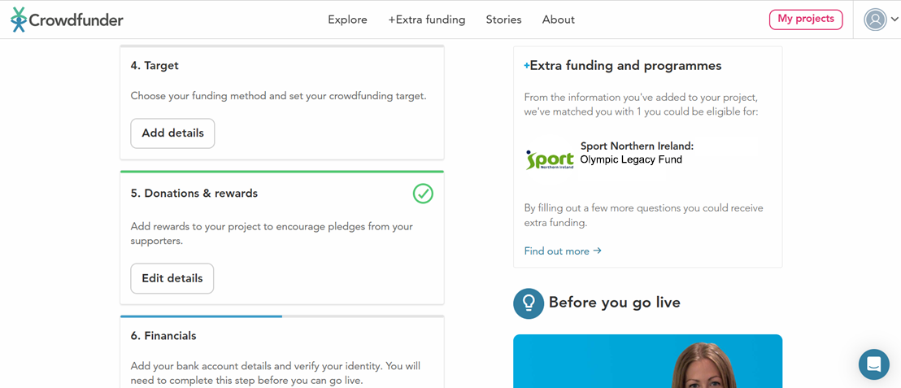

Once here, click **‘Find out more’** to apply for the Olympic Legacy fund. This will bring you into your Dashboard where you will be greeted with the prompt to apply to the funding opportunity.

Click **Apply** and go onto the next page.

This page is where you will fill in your application for Sport NI Olympic Legacy Fund. It will ask you a variety of questions regarding your application.

Go through the application page in as much detail as possible. This form will ask you a variety of questions in relation to:

* Your Organisation
* Primary Contact Details
* Secondary Contact Details
* About Your Project (how is will improve facility / engage more people in sport / physical activity)
* Declarations

Make sure to align this with your campaign page to ensure that both your campaign page and Olympic Legacy application are the same.

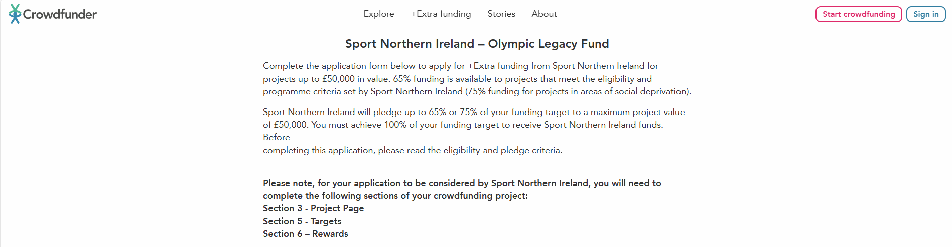

Once the application is filled in, you have ticked the declarations (ensuring your organisation meets the requirements) and are content that your campaign page/application form are complete, hit **Submit.** If you need to make changes, feel free to save and return to the application form via your dashboard to complete at any time.

Once you have clicked **Submit,** you will get notification that your application has been received.

**What’s Next?**

Sport NI will receive correspondence that you have applied to the Olympic Legacy Fund.

When we receive your application, we will be in touch with an email to confirm receipt of your application**.**

From this, your application will enter into our Application Process which you can see below in the next section.

**The Application Process**

Please see below our Application Process, which we will discuss further beneath:

Apply for the Sport NI funding via the Crowdfunding Platform. Select “Extra Funding” and click on **Sport NI Project Olympic Legacy Fund.**

Complete SNI application and click submit.

Application unsuccessfully assessed

Application successfully assessed

Applicant launches Crowdfunding campaign

Applicant reviews application and has an opportunity to successfully re-apply

Sport NI authorise Crowdfunder to release all funding

Applicant raises the **remaining funds** from their crowd to reach 100% of their target total

Applicant delivers project and spends funds as per conditions of award

If Applicant fails to reach a minimum of 18% of the target from the required minimum number of unique crowd donors **Sport NI will withhold their pledge**

Applicant raises a minimum of **18% of total target** from the required minimum number of **unique** crowd donors

Sport NI add their 65% or 75% pledge

If Applicant fails to reach 100% of their target before the campaign closing date, **Sport NI will withdraw their pledge**

**Acknowledgement:**

When we have received your application you will receive an email from us to thank you for applying.

There are 3 potential outcomes associated with an Olympic Legacy fund application which are:

* Successful
* Review
* Decline

**Successful:**

You did it! Congratulations, you have been approved and can now go live and begin to fundraise for your campaign. You will receive a letter from us indicating this outcome and the next steps you are required to take.

**Review:**

Almost there, but not quite! There are a couple of changes you are required to make before we can approve your campaign. These can include minor changes such as more detail in a certain section of your campaign page or something a little more major such as you’re missing the required video. You will receive an email from us stating what changes need to be made and how to do so.

A re-review can occurwhen you have made some changes, but not all of them. Another occasion when this happens is if we do not hear from the campaign owner within a certain timeframe after the initial ‘Review’ email has been sent. This is your last chance to make the required changes before being assessed. Again, you will receive an email from us stating what changes need to be made and how to do so.

**Decline:**

Whenever a campaign page is not eligible, it will be declined. This can be for a variety of reasons such as an ineligible project, spends that we cannot cover or if a campaign is still in template form upon submission. Additionally, those that have been given a 2nd review (Re-Review) letter but do not make the required changes, will also be declined. You will receive a letter from us indicating this outcome.

**Funding Conditions**

**t we will / will Not Fun**

As “Olympic Legacy” aims to improve the quality of offering at sports clubs and community facilities and encouraging people to engage in sport and physical activity.

Try and be creative in how you deliver your proposed project.

We are allowing sports clubs and community organisations the opportunity to be as creative as possible to help deliver the outcomes of the programme.

Below is what we will NOT invest in:

**Equipment**

* Single items under £1k in value
* Equipment not related to the applicants primary sporting activity/s
* Second hand equipment items

**Facility Modernisation**

* The applicant does not own or lease their facility. (Minimum 10 years remaining on a lease required)
* The project has not been granted planning approval prior to application.
* The project includes professional fees.
* The project requires an unrealistic procurement method.
* The applicant fails to raise 35% of the project value.
* Specifically, the fund will not support:

- Repairs to or resurfacing of carparks and driveways.

- Bar Facility (i.e. back of house – keg systems, refrigeration, drinks storage, sales systems etc).

**General**

* Retrospective capital costs or costs for projects that have already started.
* Crowdfunding campaigns that have already ‘gone live’.

It’s important to note that Sport NI will review applications **AND** your crowdfunding campaign page, make sure this is completed before sending through your application. Once you’re confident you have a strong campaign page and have been matched to our funding, you can apply. Below is **how** you request a funding pledge from Sport NI.

**Note: Campaign pages MUST be completed prior to applying to Sport NI, otherwise your application may be Declined**

Once your application has been approved for funding you **must not** change any elements of your campaign page. **Otherwise, any offer of funding will be rescinded.**

To receive a pledge, you will need to do two things:

1. **raise at least 18% of your funding target, and**
2. **receive pledges from a minimum of 30/60/90 (unique) supporters**

**If either of these funding conditions are not met, the pledge will be withheld until both have been met.**

Providing these two funding conditions are met:

* Applicants will be provided with an offer which will be valid for 2

weeks after the date of notification. If the applicant does not launch a crowdfunding campaign within 2 weeks of notification, the offer will be rescinded.

* The applicant must raise the remaining funds from the crowd to achieve 100% of your funding target and receive Sport NI funds.
* If an applicant does not achieve the funding target within the 6-week period (**4 weeks if applying in February**), Sport NI reserves the right to withdraw its support. If an applicant is within 10% of their target, Sport NI may increase the time by a further 2 weeks (**February applicants cannot be extended**).
* If the project fails to reach 100% of the target, the Sport NI funding pledge will be cancelled. The project owner will be encouraged to review what went wrong and, if appropriate, to attempt to crowdfund again.

**Scenarios You May Face**

As much as we have made this guide to ensure your success within the Olympic Legacy Fund, you may face some unexpected scenarios:

**‘We only have a few days left and won’t hit our target’**

We are aware that some circumstances are unforeseen. Therefore, we provide a maximum extension of 2 weeks. This is broken up into an initial week extension, followed by another if required. If you are applying for the funding in February, this extension may not be approved due to the narrow timeframe for delivery and spend.

**‘I don’t have a videographer to record a video’**

No problem at all – feel free to use an iPhone/Android that allows video capture in a good quality so that you can upload to the Crowdfunder platform.

**‘We aren’t gaining traction with our fundraising’**

Make sure you are using all avenues of getting eyes on your project. Social media is a powerful tool to get the word out so make sure you are using it. Use hashtags on X (formally known as Twitter) to put your campaign in the feed of other sports communities and enable the ‘share’ option on Instagram and Facebook to allow others to spread the word!

**‘We haven’t received any supporters/donations yet’**

Fundraising can take time, which is why campaigns have 6 weeks to raise their target. Make use of weekend funday fundraisers, get families involved and the community. A little from everyone goes a long way. Sometimes all it takes is a little traction and the funding will start to roll in.

**Useful Tips**

Here are some useful Tips & Tricks that will help you alongside your Crowdfunding journey:

**Get Inspiration from Successful Campaigns:**

Look at those that have already applied to the Olympic Legacy fund and have been successful! Take inspiration from these and see what sections of their campaign you like and what would also be suitable for your programme. Please do not copy and paste as you will be declined.

**Set Clear Goals and Objectives**

Define specific, measurable, achievable, relevant, and time-bound (SMART) goals for your campaign. This will help you prepare for the fundraising element.

**Understand Your Target Audience**

Research and identify the demographics and interests of your community. Tailor your campaign to those that would benefit the most.

**Leverage Social Media and Online Platforms**

Use your social media channels to promote your campaign, engage with your audience, and encourage sharing. Regular updates and interactive content can help maintain interest and expand your reach.

**Build a Pre-Launch Community**

Engage with potential supporters before launching your campaign. Building relationships and generating interest early can lead to a strong start and sustained momentum.

**Express Gratitude and Acknowledge Supporters**

Make sure to show appreciation to your backers through personalised messages or public acknowledgments. Word of mouth can go a long way!

**Get In Touch**

To get in touch with the Olympic Legacy Fund team send us an email at:

[infrastructure@sportni.net](mailto:infrastructure@sportni.net)

If your query is Crowdfunder specific, please contact our Crowdfunder support team:

E: [support@crowdfunder.co.uk](mailto:support@crowdfunder.co.uk)

**Good Luck!**

From all of us at the Sport NI Olympic Legacy team, we wish you all the best in applying for the Olympic Legacy Fund and we look forward to receiving your application.

Remember to follow this guide and you will be successful in applying. If you find yourself stuck at any point, please get in touch with us and we will help you along the way.