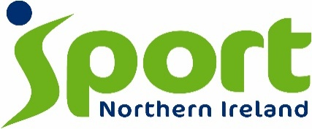

SPORT NI DISABILITY ACTION PLAN FOR 2026-2031 (CONSULTATIVE DRAFT)
RESPONSE FORM
The public consultation is open for 8 weeks, from Thursday 9th July 2026 (including public and Bank Holidays). Your comment on the plan is encouraged.
The documentation can be viewed, downloaded and responded to from the Equality section of the Sport NI website.
We would encourage you to respond to the consultation using the online questionnaire.
Confidentiality of Information
Sport NI processes personal data in accordance with the General Data Protection Regulation and in most circumstances, this means that personal data will not be disclosed to third parties. Details of the Sport NI Privacy Notice can be found on Sport NI’s website.
About You (Please click one option only)
I am responding as:
☐ A member of the public
OR
☐ On behalf of an organisation – please specify below and include your organisation’s email address

Do you agree with the actions that have been included in the Draft Disability Action Plan?
☐ Yes
☐ No
Are there any actions not included in the Draft Disability Action Plan that you feel should be included? If so, please outline these below:

Any other general comments you wish to make?

Thank you for completing this proforma.
Please return your completed proforma on or before Friday 04 September 2026.
By Email: info@sportni.net

By Post: Operations Directorate
Sport NI
House of Sport
2a Upper Malone Road
Belfast
BT9 5LA

